# EyeOS Deployment on AWS Cloud

Project report submitted

In partial fulfillment of the requirements of the degree of

**Master of Computer Applications Specialization in Cloud Computing and DevOps**

by

**Ashutosh Mago**

**21MCC2135**



**UNIVERSITY OF COMPUTING (UIC)**

**CHANDIGARH UNIVERSITY, GHARUAN, MOHALI, PUNJAB, INDIA**

**June, 2022**

**ABSTRACT**

The main scope of this project is to understand how to best utilize different cloud computing services to get good performance for less cost. Amazon EC2 gained popularity in providing good cloud computing services hence is used here and many more AWS Services used here i.e. Cloudfront, CloudWatch, CloudTrail, VPC, S3, IAM, Route 53 and many more. Cloud computing is best suited for small organizations which are worried about cost incurred in maintaining the infrastructure. Security is main concern of the cloud based computing and can be the future work of this project.

Amazon Web Services offers a broad set of global cloud-based products including compute, storage, databases, analytics, networking, mobile, developer tools, management tools, IoT, security, and enterprise applications: on-demand, available in seconds, with pay-as-you-go pricing. From data warehousing to deployment tools, directories to content delivery, over 175 AWS services are available. New services can be provisioned quickly, without the upfront capital expense. This allows enterprises, start-ups, small and medium-sized businesses, and customers in the public sector to access the building blocks they need to respond quickly to changing business requirements. This whitepaper provides you with an overview of the benefits of the AWS Cloud and introduces you to the services that make up the platform.

In this project I have given the full security to the website by using AWS Services i.e. EC2 (AMI, Load Balancer, Auto Scaling), IAM, VPC, SNS, CloudWatch, CloudTrail, CloudFront and more. By using this services the site has been secure i.e. https. In this machine if the traffic load increases automatically one new machine created.

**Table of Contents**

|  |  |  |
| --- | --- | --- |
| **S NO.** | **TOPICS** | **PAGE NO.** |
| **1** | ABSTRACT | ii |
| **2** | **Chapter 1 –** What is Cloud Computing?  1.1 Introduction   * + 1. Definition     2. Attributes     3. Services- Based     4. Scalable and Elastic     5. Shared     6. Metered by uses     7. Uses Internet Technology   1. History   2. Architecture   3. Cloud Computing Categories      1. Infrastructure as a Service      2. Software as a Service      3. Platform as a Service | 2-5 |
| **3** | **Chapter 2 –** Amazon and Cloud Computing | 6 |
| **4** | **Chapter 3 –** The Differences that Distinguish AWS  3.1 Flexible   * 1. Cost- Effective   3.3 Scalable and Elastic  3.4 Secure  3.5 Experienced | 7-12 |
| **5** | **Chapter 4 –** Amazon Web Service Cloud Platform   * 1. Compute and Networking      1. Amazon EC2      2. Auto Scaling      3. Elastic Load Balancing      4. Amazon VPC      5. Amazon Route 53   2. Storage and Content Delivery Network      1. Amazon S3      2. Amazon Glacier      3. Amazon EBS      4. AWS Storage Gateway      5. AWS Cloudfront   4.3. Databases   * + 1. Amazon RDS   1. Application Servive      1. Amazon SQS      2. Amazon SNS      3. Amazon SES   2. Deployment and Management      1. AWS IAM      2. AWS CloudTrail      3. AWS CloudWatch      4. AWS Elastic Beanstalk | 13-21 |
| **6** | **Chapter 5 –** About the Project (eyeOS)   * 1. Introduction   2. History   3. Architecture Overview   4. What is a process inside eyeOS   5. Security   6. Features   7. Market View   8. Advantages   9. Disadvantages   10. Application Domain   11. Future Scope | 22-31 |
| **7** | **Chapter 6 –** My Project Screenshot | 32-49 |
| **8** | **CONCLUSIONS** | 50 |
| **9** | **REFERENCES** | 51-52 |

**LIST OF FIGURES**

|  |  |  |
| --- | --- | --- |
| **FIGURE NO.** | **TOPICS** | **PAGE NO.** |
| **1** | Virtual Private Cloud Schema | 5 |
| **2** | AWS Global Physical Infrastructure | 13 |
| **3** | IAM Architecture | 20 |
| **4** | Centering work and entertainment in a single place | 23 |
| **5** | Architecture Overview of eyeOS | 24 |
| **6** | Working of eyeOS in kernel | 25 |
| **7** | Application Domain in eyeOS | 30 |
| **8** | Create VPC | 32 |
| **9** | Create Subnets | 33 |
| **10** | Create Route Tables | 33 |
| **11** | Create Internet Gateway | 34 |
| **12** | Create NAT Gateway | 34 |
| **13** | Create IAM | 35 |
| **14** | Create S3 | 35 |
| **15** | Create EC2 Instances | 36 |
| **16** | EyeOS Project running on Server | 37 |
| **17** | EyeOS Installation | 38 |
| **18** | After Installation | 38 |
| **19** | Freenom website for Domain | 39 |
| **20** | Create ACM Certificate | 39 |
| **21** | Create Route 53 | 40 |
| **22** | EyeOS Project running with Domain on Server | 40 |
| **23** | After login eyeOS Project | 41 |
| **24** | Create Elastic Load Balancer | 41 |
| **25** | Open with Load Balancer Domain Name | 42 |
| **26** | Delete and create New Record with Simple Routing with Route 53 | 42 |
| **27** | EyeOS Project Secure with HTTPS | 43 |
| **28** | Create AMI | 43 |
| **29** | Create Launch Configurations | 44 |
| **30** | Create Auto Scaling Group | 44 |
| **31** | Create Cloudfront | 45 |
| **32** | Deleting all the Record in Route 53 and making a new Record in Route 53 and attached with cloudfront in Route 53 | 45 |
| **33** | Opened with Cloudfront Domain Name | 46 |
| **34** | Create Cloudwatch | 46 |
| **35** | Create SNS Topic | 47 |
| **36** | Create SNS Subscription | 47 |
| **37** | Create Cloudtrail | 48 |
| **38** | After stopping the machine automatically another machine created | 48 |
| **39** | Command Run on Putty Software | 49 |



**Overview of Amazon Web Services**

**Chapter 1**

**What is Cloud Computing?**

**1.1 Introduction**

This text provides you with a basic information about the Cloud Computing, a new and fastly growing term. It is structured to seven chapters for better orientation and easy understanding. The first chapter talks about the very basis such as definition, its attributes or history.[1]

* + 1. **Definition:** Cloud Computing is a buzzword of 2010 and many experts disagree on its exact definition. But the most used one and concurred one includes the notion of web‐based services which are available on demand from and optimized and highly scalable service provider. Since such a disagreement on the definition, one will be provided to better understand of the notion. The cloud is IT as a service, delivered by IT resources that are independent of location. It is a style of computing in which dynamically scalable and often virtualized resources are provided as a service over the Internet where end‐users have no knowledge of, expertise in, or control over the technology infrastructure (the cloud) that supports them.
    2. **Attributes:** Before some of the attributes will be defined, the term cloud should be explained. A cloud has been long used in IT, in network diagrams respectively, to represent a sort of black box where the interfaces are well known but the internal routing and processing is not visible to the network users. Key attributes in cloud computing:
    3. **Service‐Based*:*** Consumer concerns are abstracted from provider concerns through service interfaces that are well‐defined. The interfaces hide the implementation details and enable a completely automated response by the service provider. The service could be considered "ready to use" or "off the shelf" because it is designed to serve the specific needs of a set of consumers, and the technologies are tailored to that need rather than the service being tailored to how the technology works. The articulation of the service feature is based on service levels and IT outcomes such as availability, response time, performance versus price, and clear and predefined operational processes, rather than technology and its capabilities. In other words, what the service needs to do is more important than how the technologies are used to implement the solution.
    4. **Scalable and Elastic*:*** The service can scale capacity up or down as the consumer demands at the speed of full automation (from seconds for some services to hours for others). Elasticity is a trait of shared pools of resources. Scalability is a feature of the underlying infrastructure and software platforms. Elasticity is associated with not only scale but also an economic model that enables scaling in both directions in an automated fashion. This means that services scale on demand to add or remove resources as needed.
    5. **Shared:**Services share a pool of resources to build economies of scale and IT resources are used with maximum efficiency. The underlying infrastructure, software or platforms are shared among the consumers of the service (usually unknown to the consumers). This enables unused resources to serve multiple needs for multiple consumers, all working at the same time.
    6. **Metered by Use**: Services are tracked with usage metrics to enable multiple payment models. The service provider has a usage accounting model for measuring the use of the services, which could then be used to create different pricing plans and models. These may include pay‐as‐you go plans, subscriptions, fixed plans and even free plans. The implied payment plans will be based on usage, not on the cost of the equipment. These plans are based on the amount of the service used by the consumers, which may be in terms of hours, data transfers or other use‐based attributes delivered.
    7. **Uses Internet Technologies**: The service is delivered using Internet identifiers, formats and protocols, such as URLs, HTTP, IP and representational state transfer Web‐oriented architecture. Many examples of Web technology exist as the foundation for Internet‐based services. Google's Gmail, Amazon.com's book buying, eBay's auctions sharing all exhibit the use of Internet and Web technologies and protocols. More details about examples are in the chapter four – Intergration
  1. **History**

History of Cloud Computing surprisingly began almost 50 years ago. The father of this idea is considered to be John McCarthy, a professor at MIT University in US, who first in 1961 presented the idea of sharing the same computer technology as being the same as for example sharing electricity. Electrical power needs many households/firms that possess a variety of electrical appliances but do not possess power plant. One power plant serves many customers and using the electricity example, power plant=service provider, distribution network=internet and the households/firms=computers.

Since that time, Cloud computing has evolved through a number of phases which include grid and utility computing, application service provision (ASP), and Software as a Service (SaaS). One of the first milestones was the arrival of Salesforce.com in 1999, which pioneered the concept of delivering enterprise applications via a simple website. The next development was Amazon Web Services in 2002, which provided a suite of cloud‐based services including storage, computation and even human intelligence. Another big milestone came in 2009 as Google and others started to offer browser‐based enterprise applications, though services such as Google Apps.

* 1. **Architecture**

A basis infromation about the architecture is provided in this chapter, together with the explanations of relevant terms such as virtualization, Frond/Back end or Middleware.

* Virtualization is best described as essentially designating one computer to do the job of multiple computers by sharing the resources of that single computer across multiple environments. Virtual servers and virtual desktops allow you to host multiple operating systems and multiple applications locally and in remote locations, freeing your business from physical and geographical limitations.

The Cloud Computing architecture can be divided into two sections, the front end and the back end, connected together through a network, usually Internet. The **Front End** includes the client's computer and the application required to access the cloud computing system. Not all cloud computing systems have the same user interface. Services like Web‐based e‐mail programs leverage existing Web browsers like Internet Explorer or Firefox. Other systems have unique applications that provide network access to clients.

The **Back End** of the system is represented by various computers, servers and data storage systems that create the "cloud" of computing services. Practically, Cloud Computing system could include any program, from data processing to video games and each application will have its own server.

A central server administers the system, monitoring traffic and client demands to ensure everything runs smoothly. It follows a set of rules called protocols and uses a special kind of software called **Middleware**. Middleware allows networked computers to communicate with each other.

**Public Cloud** (external cloud) is a model where services are available from a provider over the Internet, such as applications and storage. There are free Public Cloud Services available, as well as pay‐per‐usage or other monetized models. **Private Cloud** (Internal Cloud/Corporate Cloud) is computing architecture providing hosted services to a limited number of people behind a company’s protective firewall and it sometimes attracts criticism as firms still have to buy, build, and manage some resources and thus do not benefit from lower up‐front capital costs and less hands‐on management, the core concept of Cloud Computing.



**Figure 1: Virtual Private Cloud Schema**

* 1. **Cloud computing categories**

There are three main categories in CC, Infrastructure as a Service (IaaS), Software as a Service (SaaS) and Platform as a Service (PaaS). All of them are described below in more details.

* + 1. **Infrastructure as a Service** is a provision model in which an organization outsources the equipment used to support operations, including storage, hardware, servers and networking components. The service provider owns the equipment and is responsible for housing, running and maintaining it.
    2. **Software as a Service** is a software distribution model in which applications are hosted by a vendor or service provider and made available to customers over a network, typically the Internet. It is becoming an increasingly prevalent delivery model as underlying technologies that support Web services and service‐oriented architecture become increasingly available.
    3. **Platform as a Service** is an outgrowth of Software as a Service (SaaS). It is a way to rent hardware, operating systems, storage and network capacity over the Internet. The service delivery model allows the customer to rent virtualized servers and associated services for running existing applications or developing and testing new ones.

**Chapter 2**

**Amazon and Cloud Computing**

Amazon has a long history of using a decentralized IT infrastructure. This arrangement enabled our development teams to access compute and storage resources on demand, and it has increased overall productivity and agility. By 2005, Amazon had spent over a decade and millions of dollars building and managing the large-scale, reliable, and efficient IT infrastructure that powered one of the world’s largest online retail platforms. Amazon launched Amazon Web Services (AWS) so that other organizations could benefit from Amazon’s experience and investment in running a large-scale distributed, transactional IT infrastructure. AWS has been operating since 2006, and today serves hundreds of thousands of customers worldwide. Today Amazon.com runs a global web platform serving millions of customers and managing billions of dollars’ worth of commerce every year.[2]

Using AWS, you can requisition compute power, storage, and other services in minutes and have the flexibility to choose the development platform or programming model that makes the most sense for the problems they’re trying to solve.

You pay only for what you use, with no up-front expenses or long-term commitments, making AWS a cost-effective way to deliver applications.

Here are some of examples of how organizations, from research firms to large enterprises, use AWS today:

* A large enterprise quickly and economically deploys new internal applications, such as HR solutions, payroll applications, inventory management solutions, and online training to its distributed workforce.
* An e-commerce website accommodates sudden demand for a “hot” product caused by viral buzz from Facebook and Twitter without having to upgrade its infrastructure.
* A pharmaceutical research firm executes large-scale simulations using computing power provided by AWS. Media companies serve unlimited video, music, and other media to their worldwide customer base.

**Chapter 3**

**The Differences that Distinguish AWS**

AWS is readily distinguished from other vendors in the traditional IT computing landscape because it is:

* 1. **Flexible**. AWS enables organizations to use the programming models, operating systems, databases, and architectures with which they are already familiar. In addition, this flexibility helps organizations mix and match architectures in order to serve their diverse business needs.
  2. **Cost-effective**. With AWS, organizations pay only for what they use, without up-front or long-term commitments.
  3. **Scalable and elastic**. Organizations can quickly add and subtract AWS resources to their applications in order to meet customer demand and manage costs.
  4. **Secure**. In order to provide end-to-end security and end-to-end privacy, AWS builds services in accordance with security best practices, provides the appropriate security features in those services, and documents how to use those features.
  5. **Experienced**. When using AWS, organizations can leverage Amazon’s more than fifteen years of experience delivering large-scale, global infrastructure in a reliable, secure fashion.[3]
  6. **Flexible**

The first key difference between AWS and other IT models is *flexibility*. Using traditional models to deliver IT solutions often requires large investments in new architectures, programming languages, and operating systems. Although these investments are valuable, the time that it takes to adapt to new technologies can also slow down your business and prevent you from quickly responding to changing markets and opportunities. When the opportunity to innovate arises, you want to be able to move quickly and not always have to support legacy infrastructure and applications or deal with protracted procurement processes.

In contrast, the flexibility of AWS allows you to keep the programming models, languages, and operating systems that you are already using or choose others that are better suited for their project. You don’t have to learn new skills.

Flexibility means that migrating legacy applications to the cloud is easy and cost-effective. Instead of re-writing applications, you can easily move them to the AWS cloud and tap into advanced computing capabilities.

Building applications on AWS is very much like building applications using existing hardware resources. Since AWS provides a flexible, virtual IT infrastructure, you can use the services together as a platform or separately for specific needs. AWS run almost anything—from full web applications to batch processing to offsite data back-ups.

In addition, you can move existing SOA-based solutions to the cloud by migrating discrete components of legacy applications. Typically, these components benefit from high availability and scalability, or they are self-contained applications with few internal dependencies. Larger organizations typically run in a hybrid mode where pieces of the application run in their data center and other portions run in the cloud. Once these organizations gain experience with the cloud, they begin transitioning more of their projects to the cloud, and they begin to appreciate many of the benefits outlined in this document. Ultimately, many organizations see the unique advantages of the cloud and AWS and make it a permanent part of their IT mix. Finally, AWS provides you flexibility when provisioning new services. Instead of the weeks and months it takes to plan, budget, procure, set up, deploy, operate, and hire for a new project, you can simply sign up for AWS and immediately begin deployment on the cloud the equivalent of 1, 10, 100, or 1,000 servers. Whether you want to prototype an application or host a production solution, AWS makes it simple for you to get started and be productive. Many customers find the flexibility of AWS to be a great asset in improving time to market and overall organizational productivity.

* 1. **Cost-Effective**

Cost is one of the most complex elements of delivering contemporary IT solutions. It seems that for every advance that will save money, there is often a commensurate investment needed to realize that savings. For example, developing and deploying an e-commerce application can be a low-cost effort, but a successful deployment can increase the need for hardware and bandwidth. Furthermore, owning and operating your own infrastructure can incur considerable costs, including power, cooling, real estate, and staff.

In contrast, the cloud provides an on-demand IT infrastructure that lets you consume only the amount of resources that you actually need. You are not limited to a set amount of storage, bandwidth, or computing resources. It is often difficult to predict requirements for these resources. As a result, you might provision too few resources, which has an impact on customer satisfaction, or you might provide too many resources and miss an opportunity to maximize return on investment (ROI) through full utilization.

The cloud provides the flexibility to strike the right balance. AWS requires no up-front investment, long-term commitment, or minimum spend. You can get started through a completely self-service experience online, scale up and down as needed, and terminate your relationship with AWS at any time. You can access new resources almost instantly. The ability to respond quickly to changes, no matter how large or small, means that you can take on new opportunities and meet business challenges that could drive revenue and reduce costs. If you want to consult with AWS for deeper technical discussions, our sales and solutions architecture teams are available.

* 1. **Scalable and Elastic**

In the traditional IT organization, scalability and elasticity were often equated with investment and infrastructure. In the cloud, scalability and elasticity provide opportunity for savings and improved ROI. AWS uses the term elastic to describe the ability to scale computing resources up and down easily, with minimal friction. Elasticity helps you avoid provisioning resources up front for projects with variable consumption rates or short lifetimes. Instead of acquiring hardware, setting it up, and maintaining it in order to allocate resources to your applications, you use AWS to allocate resources using simple API calls.

Imagine what would happen to a traditional IT shop if traffic to an application doubled or tripled in a short period. For example, during benefits open enrollment periods, many corporate users generate significant traffic to internal applications. You need to be confident that your existing infrastructure can handle a spike in traffic, and that the spike will not interfere with normal business operations. Elastic Load Balancing and Auto Scaling can automatically scale your AWS cloud-based resources up to meet unexpected demand, and then scale those resources down as demand decreases.

The AWS cloud is also a useful resource for implementing short-term jobs, mission-critical jobs, and jobs repeated at regular intervals. For example, when a pharmaceutical company needs to run drug simulations (a short-term job), it can use AWS to spin up resources in the cloud, and then shut them down when it no longer needs additional resources.

When an enterprise has to quickly deal with the effects of natural disaster on its data center (a mission-critical job), it can use AWS to tap into new storage and computing resources to accommodate demand. Furthermore, AWS can preserve computing resources and reduce costs for regularly repeated tasks, such as month-end payroll or invoice processing.

* 1. **Secure**

AWS delivers a scalable cloud-computing platform that provides customers with end-to-end security and end-to-end privacy. AWS builds security into its services in accordance with security best practices, and documents how to use the security features. It is important that you leverage AWS security features and best practices to design an appropriately secure application environment.

Ensuring the confidentiality, integrity, and availability of your data is of the utmost importance to AWS, as is maintaining your trust and confidence. AWS takes the following approaches to secure the cloud infrastructure:

**Certifications and accreditations.** AWS has in the past successfully completed multiple SAS70 Type II audits, and now publishes a Service Organization Controls 1 (SOC 1) report, published under both the SSAE 16 and the ISAE 3402 professional standards. In addition to the SOC 1 report, AWS publishes a Service Organization Controls 2 (SOC 2), Type II report. Similar to the SOC 1 in the evaluation of controls, the SOC 2 report is an attestation report that expands the evaluation of controls to the criteria set forth by the American Institute of Certified Public Accountants (AICPA) Trust Services Principles. Additionally, AWS publishes a Service Organization Controls 3 (SOC 3) report . The SOC 3 report is a publically-available summary of the AWS SOC 2 report and provides the AICPA SysTrust Security Seal. The report includes the external auditor’s opinion of the operation of controls (based on the AICPA’s Security Trust Principles included in the SOC 2 report), the assertion from AWS management regarding the effectiveness of controls, and an overview of AWS Infrastructure and Services. In addition, AWS has achieved ISO 27001 certification, and has been successfully validated as a Level 1 service provider under the Payment Card Industry (PCI) Data Security Standard (DSS).

In the realm of public sector certifications, AWS has achieved Agency Authority to Operate (ATOs) under the Federal Risk and Authorization Management Program (FedRAMP) at the Moderate impact level for AWS GovCloud (US) and all US regions. The AWS ATOs are the result of a comprehensive, independent assessment of the FedRAMP control requirements. The authorization package can be leveraged by all federal, state, and local governments. AWS enables US government agencies to achieve and sustain compliance with the Federal Information Security Management Act (FISMA). The AWS infrastructure has been evaluated by independent assessors for a variety of government systems as part of their system owners’ approval process. Numerous Federal Civilian and Department of Defense (DoD) organizations have successfully achieved security authorizations for systems hosted on AWS in accordance with the Risk Management Framework (RMF) process defined in NIST 800-37 and DoD Information Assurance Certification and Accreditation Process (DIACAP). AWS’s secure infrastructure has helped federal agencies expand cloud computing use cases and deploy sensitive government data and applications in the cloud while complying with the rigorous security requirements of federal standards. We will continue to obtain the appropriate security certifications and conduct audits to demonstrate the security of our infrastructure and services. The AWS GovCloud (US) region supports US International Traffic in Arms Regulations (ITAR) compliance. As a part of managing a comprehensive ITAR compliance program, companies subject to ITAR export regulations must control unintended exports by restricting access to protected data to US Persons and restricting physical location of that data to the US. AWS GovCloud (US) provides an environment physically located in the US and where access by AWS Personnel is limited to US Persons, thereby allowing qualified companies to transmit, process, and store protected articles and data subject to ITAR restrictions. The AWS GovCloud (US) environment has been audited by an independent third-party to validate the proper controls are in place to support customer export compliance programs for this requirement. AWS will continue to obtain the appropriate security certifications and accreditations to demonstrate the security of our infrastructure and services.

**Physical security**. Amazon has many years of experience designing, constructing, and operating large-scale data centers. The AWS infrastructure is located in Amazon-controlled data centers throughout the world.

Knowledge of the location of the data centers is limited to those within Amazon who have a legitimate business reasons for this information. The data centers are physically secured in a variety of ways to prevent unauthorized access.

**Secure services**. Each service in the AWS cloud is architected to be secure. The services contain a number of capabilities that restrict unauthorized access or usage without sacrificing the flexibility that customers demand.

**Data privacy**. You can encrypt personal and business data in the AWS cloud, and publish backup and redundancy procedures for services so that your customers can protect their data and keep their applications running.

* 1. **Experienced**

AWS provides a low-friction path to cloud computing by design. Nevertheless, as with any IT project, the move to the AWS cloud should be done thoughtfully. You should hold your cloud-computing partner to the same high standards that you would expect of any hardware or software vendor. The trust that you place in your cloud-computing vendor will be critical as your organization grows and your customers continue to expect the best experience.

The AWS cloud provides levels of scale, security, reliability, and privacy that are often cost-prohibitive for many organizations to meet or exceed. AWS has built an infrastructure based on lessons learned from over sixteen years’ experience managing the multi-billion dollar Amazon.com business. AWS customers benefit as Amazon continues to hone its infrastructure management skills and capabilities. Today Amazon.com runs a global web platform serving millions of customers and managing billions of dollars’ worth of commerce every year. AWS has been operating since 2006, and today serves hundreds of thousands of customers worldwide.

Moreover, AWS has a demonstrated track record of listening to its customers and delivering highly innovative new features at a rapid pace. These new releases have the same high standards of security and reliability that are demonstrated in all existing AWS infrastructure services.

In addition to new services, AWS constantly hones its operational expertise to ensure ongoing dependability, and we continue to incorporate both industry best practices and proprietary advances into the cloud infrastructure. Choosing AWS as a cloud-computing provider allows you to take advantage of these ongoing investments.

**Chapter 4**

**Amazon Web Services Cloud Platform**

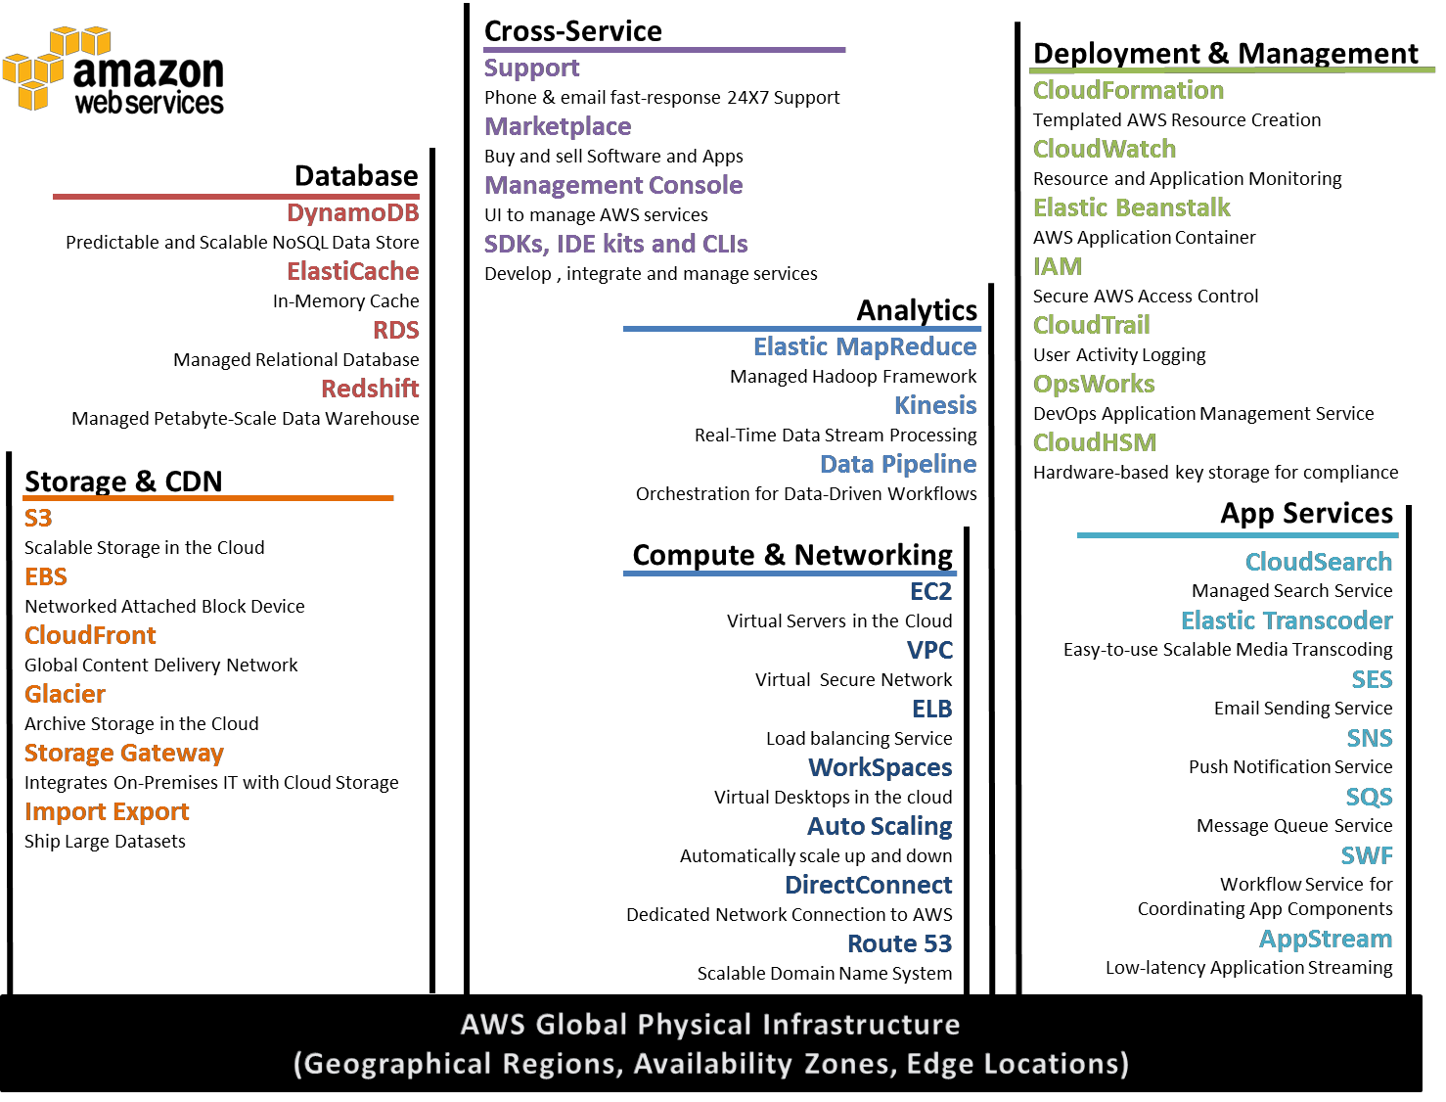AWS is a comprehensive cloud services platform that offers compute power, storage, content delivery, and other functionality that organizations can use to deploy applications and services cost-effectively—with flexibility, scalability, and reliability. AWS self-service means that you can proactively address your internal plans and react to external demands when you choose.[4]

**Figure 2: AWS Global Physical Infrastructure**

* 1. **Compute & Networking**

**4.1.1 Amazon Elastic Compute Cloud (Amazon EC2)**

Amazon Elastic Compute Cloud (Amazon EC2) is a web service that provides resizable compute capacity in the cloud. It is designed to make web-scale computing easier for developers and system administrators.

Amazon EC2’s simple web service interface allows you to obtain and configure capacity with minimal friction. It provides you with complete control of your computing resources and lets you run on Amazon’s proven computing environment. Amazon EC2 reduces the time required to obtain and boot new server instances to minutes, allowing you to quickly scale capacity, both up and down, as your computing requirements change. Amazon EC2 changes the economics of computing by allowing you to pay only for capacity that you actually use. Amazon EC2 provides developers and system administrators the tools to build failure resilient applications and isolate themselves from common failure scenarios.[5]

**4.1.2 Auto Scaling**

Auto Scaling allows you to scale your Amazon EC2 capacity up or down automatically according to conditions you define. With Auto Scaling, you can ensure that the number of Amazon EC2 instances you’re using increases seamlessly during demand spikes to maintain performance, and decreases automatically during demand lulls to minimize costs. Auto Scaling is particularly well suited for applications that experience hourly, daily, or weekly variability in usage. Auto Scaling is enabled by Amazon CloudWatch and available at no additional charge beyond Amazon CloudWatch fees.[6]

**4.1.3 Elastic Load Balancing**

Elastic Load Balancing automatically distributes incoming application traffic across multiple Amazon EC2 instances. It enables you to achieve even greater fault tolerance in your applications, seamlessly providing the amount of load balancing capacity needed in response to incoming application traffic. Elastic Load Balancing detects unhealthy instances and automatically reroutes traffic to healthy instances until the unhealthy instances have been restored. Customers can enable Elastic Load Balancing within a single Availability Zone or across multiple zones for even more consistent application performance.[7]

**4.1.4 Amazon Virtual Private Cloud (Amazon VPC)**

Amazon Virtual Private Cloud lets you provision a logically isolated section of the Amazon Web Services (AWS) Cloud where you can launch AWS resources in a virtual network that you define. You have complete control over your virtual networking environment, including selection of your own IP address range, creation of subnets, and configuration of route tables and network gateways.

You can easily customize the network configuration for your Amazon VPC. For example, you can create a public-facing subnet for your webservers that has access to the Internet, and place your backend systems such as databases or application servers in a private-facing subnet with no Internet access. You can leverage multiple layers of security (including security groups and network access control lists) to help control access to Amazon EC2 instances in each subnet. Additionally, you can create a hardware virtual private network (VPN) connection between your corporate data center and your VPC and leverage the AWS cloud as an extension of your corporate data center.[8]

* + 1. **Amazon Route 53**

Amazon Route 53 is a highly available and scalable Domain Name System (DNS) web service. It is designed to give developers and businesses an extremely reliable and cost-effective way to route end users to Internet applications by translating human readable names, such as [www.example.com,](http://www.example.com/) into the numeric IP addresses, such as 192.0.2.1, that computers use to connect to each other. Route 53 effectively connects user requests to infrastructure running in AWS, such as an EC2 instance, an elastic load balancer, or an Amazon S3 bucket. Route 53 can also be used to route users to infrastructure outside of AWS.

Amazon Route 53 is designed to be fast, easy to use, and cost effective. It answers DNS queries with low latency by using a global network of DNS servers. Queries for your domain are automatically routed to the nearest DNS server, and thus are answered with the best possible performance. With Route 53, you can create and manage your public DNS records with the AWS Management Console or with an easy-to-use API. It’s also integrated with other Amazon Web Services. For instance, by using the AWS Identity and Access Management (IAM) service with Route 53, you can control who in your organization can make changes to your DNS records. Like other Amazon Web Services, there are no long-term contracts or minimum usage requirements for using Route 53—you pay only for managing domains through the service and the number of queries that the service answers.[9]

* 1. **Storage & Content Delivery Network**

**4.2.1 Amazon Simple Storage Service (Amazon S3)**

Amazon S3 is storage for the Internet. It is designed to make web-scale computing easier for developers.

Amazon S3 provides a simple web services interface that can be used to store and retrieve any amount of data, at any time, from anywhere on the web. The container for objects stored in Amazon S3 is called an Amazon S3 bucket. Amazon S3 gives any developer access to the same highly scalable, reliable, secure, fast, inexpensive infrastructure that Amazon uses to run its own global network of websites. The service aims to maximize benefits of scale and to pass those benefits on to developers.[10]

**4.2.2 Amazon Glacier**

Amazon Glacier is an extremely low-cost storage service that provides secure and durable storage for data archiving and backup. In order to keep costs low, Amazon Glacier is optimized for data that is infrequently accessed and for which retrieval times of several hours are suitable. With Amazon Glacier, customers can reliably store large or small amounts of data for as little as $0.01 per gigabyte per month, a significant savings compared to on-premises solutions.

Companies typically over-pay for data archiving. First, they're forced to make an expensive upfront payment for their archiving solution (which does not include the ongoing cost for operational expenses such as power, facilities, staffing, and maintenance). Second, since companies have to guess what their capacity requirements will be, they understandably over-provision to make sure they have enough capacity for data redundancy and unexpected growth. This set of circumstances results in under-utilized capacity and wasted money. With Amazon Glacier, you pay only for what you use. Amazon Glacier changes the game for data archiving and backup because you pay nothing up front, pay a very low price for storage, and can scale your usage up or down as needed, while AWS handles all of the operational heavy lifting required to do data retention well. It only takes a few clicks in the AWS Management Console to set up Amazon Glacier, and then you can upload any amount of data you choose.

**4.2.3 Amazon Elastic Block Storage (EBS)**

Amazon Elastic Block Store (EBS) provides block level storage volumes for use with Amazon EC2 instances. Amazon EBS volumes are network-attached, and persist independently from the life of an instance. Amazon EBS provides highly available, highly reliable, predictable storage volumes that can be attached to a running Amazon EC2 instance and exposed as a device within the instance. Amazon EBS is particularly suited for applications that require a database, file system, or access to raw block level storage.[11]

**4.2.4 AWS Storage Gateway**

AWS Storage Gateway is a service connecting an on-premises software appliance with cloud-based storage to provide seamless and secure integration between an organization’s on-premises IT environment and AWS’s storage infrastructure. The service enables you to securely upload data to the AWS cloud for cost-effective backup and rapid disaster recovery. AWS Storage Gateway supports industry-standard storage protocols that work with your existing applications. It provides low-latency performance by maintaining data on your on-premises storage hardware while asynchronously uploading this data to AWS, where it is encrypted and securely stored in Amazon Simple Storage Service (Amazon S3) or Amazon Glacier.

Using AWS Storage Gateway, you can back up point-in-time snapshots of your on-premises application data to Amazon S3 for future recovery. In the event you need replacement capacity for disaster recovery purposes, or if you want to leverage Amazon EC2’s on-demand compute capacity for additional capacity during peak periods, for new projects, or as a more cost-effective way to run your normal workloads, you can use AWS Storage Gateway to mirror your on-premises data to Amazon EC2 instances.

**4.2.5 Amazon CloudFront**

Amazon CloudFront is a content delivery web service. It integrates with other Amazon Web Services to give developers and businesses an easy way to distribute content to end users with low latency, high data transfer speeds, and no commitments.

Amazon CloudFront can be used to deliver your entire website, including dynamic, static and streaming content using a global network of edge locations. Requests for objects are automatically routed to the nearest edge location, so content is delivered with the best possible performance. Amazon CloudFront is optimized to work with other Amazon Web Services, like Amazon S3 and Amazon EC2. Amazon CloudFront also works seamlessly with any origin server, which stores the original, definitive versions of your files. Like other Amazon Web Services, there are no contracts or monthly commitments for using Amazon CloudFront—you pay only for as much or as little content as you actually deliver through the service.[12]

* 1. **Databases**

**4.3.1 Amazon Relational Database Service (Amazon RDS)**

Amazon Relational Database Service (Amazon RDS) is a web service that makes it easy to set up, operate, and scale a relational database in the cloud. It provides cost-efficient and resizable capacity while managing time-consuming database administration tasks, freeing you up to focus on your applications and business.

Amazon RDS gives you access to the capabilities of a familiar MySQL, Oracle, SQL Server or PostgreSQL database. This means that the code, applications, and tools you already use today with your existing databases can be used with Amazon RDS. Amazon RDS automatically patches the database software and backs up your database, storing the backups for a retention period that you define and enabling point-in-time recovery. You benefit from the flexibility of being able to scale the compute resources or storage capacity associated with your relational database instance by using a single API call. In addition, Amazon RDS makes it easy to use replication to enhance availability and reliability for production databases and to scale out beyond the capacity of a single database deployment for read-heavy database workloads.

* 1. **Application Services**

**4.4.1 Amazon Simple Queue Service (Amazon SQS)**

Amazon Simple Queue Service (Amazon SQS) is a fast, reliable, scalable, fully managed message queuing service. SQS makes it simple and cost-effective to decouple the components of a cloud application. You can use SQS to transmit any volume of data, at any level of throughput, without losing messages or requiring other services to be always available.

With SQS, you can offload the administrative burden of operating and scaling a highly available messaging cluster, while paying a low price for only what you use.[13]

**4.4.2 Amazon Simple Notification Service (Amazon SNS)**

Amazon Simple Notification Service (Amazon SNS) Amazon Simple Notification Service (SNS) is a fast, flexible, fully managed push messaging service. SNS makes it simple and cost-effective to push to mobile devices such as iPhone, iPad, Android, Kindle Fire, and internet connected smart devices, as well as pushing to other distributed services.

Besides pushing cloud notifications directly to mobile devices, SNS can also deliver notifications by SMS text message or email, to Simple Queue Service (SQS) queues, or to any HTTP endpoint.[14]

To prevent messages from being lost, all messages published to Amazon SNS are stored redundantly across multiple availability zones.

**4.4.3 Amazon Simple Email Service (Amazon SES)**

Amazon Simple Email Service (Amazon SES) is a highly scalable and cost-effective bulk and transactional email sending service for organizations and developers. Amazon SES eliminates the complexity and expense of building an in-house email solution or licensing, installing, and operating a third-party email service. The service integrates with other AWS services, making it easy to send emails from applications that are hosted on services such as Amazon EC2. With Amazon SES there is no long-term commitment, minimum spend, or negotiation required. Organizations can utilize a free usage tier and after that enjoy low fees for the number of emails sent plus data transfer fees.

Building large-scale email solutions to send marketing and transactional messages is often a complex and costly challenge for organizations. To optimize the percentage of emails that are successfully delivered, organizations must deal with email server management and network configuration, plus they must meet rigorous Internet service provider (ISP) standards for email content. Additionally, many third-party email solutions require contract and price negotiations, as well as significant up-front costs.

Amazon SES eliminates these challenges and enables organizations to benefit from the years of experience and sophisticated email infrastructure Amazon.com has built to serve its own large-scale customer base. Using SMTP or a simple API call, an organization can now access a high-quality, scalable email infrastructure to efficiently and inexpensively communicate to their customers. For high email deliverability, Amazon SES uses content filtering technologies to scan an organization’s outgoing email messages to help ensure that the content meets ISP standards. The email message is then either queued for sending or routed back to the sender for corrective action. To help organizations further improve the quality of email communications with their customers, Amazon SES provides a built-in feedback loop, which includes notifications of bounce backs, failed and successful delivery attempts, and spam complaints.

* 1. **Deployment and Management**

**4.5.1 AWS Identity and Access Management (IAM)**

AWS Identity and Access Management (IAM) enables you to securely control access to AWS services and resources for your users. Using IAM, you can create and manage AWS users and groups and use permissions to allow and deny their access to AWS resources. IAM allows you to:

Manage IAM users and their access - You can create users in IAM, assign them individual security credentials (i.e., access keys, passwords, and Multi-Factor Authentication devices) or request temporary security credentials to provide users access to AWS services and resources. You can manage permissions in order to control which operations a user can perform.[15]

Manage IAM roles and their permissions - You can create roles in IAM, and manage permissions to control which operations can be performed by the entity, or AWS service, that assumes the role. You can also define which entity is allowed to assume the role.

Manage federated users and their permissions - You can enable identity federation to allow existing identities (e.g.

users) in your enterprise to access the AWS Management Console, to call AWS APIs, and to access resources, without the need to create an IAM user for each identity

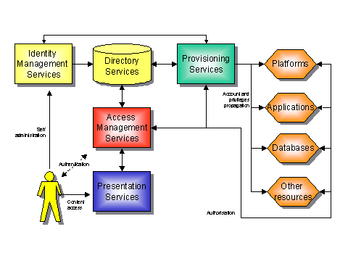

**Figure 3: IAM Architecture**

**4.5.2 AWS CloudTrail**

AWS CloudTrail is a web service that records AWS API calls for your account and delivers log files to you. The recorded information includes the identity of the API caller, the time of the API call, the source IP address of the API caller, the request parameters, and the response elements returned by the AWS service.[16]

With CloudTrail, you can get a history of AWS API calls for your account, including API calls made via the AWS Management Console, AWS SDKs, command line tools, and higher-level AWS services (such as AWS CloudFormation). The AWS API call history produced by CloudTrail enables security analysis, resource change tracking, and compliance auditing.

**4.5.3 Amazon CloudWatch**

Amazon CloudWatch provides monitoring for AWS cloud resources and the applications customers run on AWS. Developers and system administrators can use it to collect and track metrics, gain insight, and react immediately to keep their applications and businesses running smoothly. Amazon CloudWatch monitors AWS resources such as Amazon EC2 and Amazon RDS DB Instances, and can also monitor custom metrics generated by a customer’s applications and services. With Amazon CloudWatch, you gain system-wide visibility into resource utilization, application performance, and operational health.[17]

Amazon CloudWatch provides a reliable, scalable, and flexible monitoring solution that you can start using within minutes. You no longer need to set up, manage, or scale your own monitoring systems and infrastructure. Using Amazon CloudWatch, you can easily monitor as much or as little metric data as you need. Amazon CloudWatch lets you programmatically retrieve your monitoring data, view graphs, and set alarms to help you troubleshoot, spot trends, and take automated action based on the state of your cloud environment.

**4.5.4 AWS Elastic Beanstalk**

AWS Elastic Beanstalk is an easy-to-use service for deploying and scaling web applications and services developed with popular programming languages such as **Java, .NET, PHP, Node.js, Python and Ruby**. You simply upload your application and Elastic Beanstalk automatically handles the deployment details of capacity provisioning, load balancing, auto-scaling and application health monitoring. At the same time, with Elastic Beanstalk, you retain full control over the AWS resources powering your application and can access the underlying resources at anytime.

Most existing application containers or platform-as-a-service solutions, while reducing the amount of programming required, significantly diminish developers' flexibility and control. Developers are forced to live with all the decisions pre- determined by the vendor - with little to no opportunity to take back control over various parts of their application's infrastructure. However, with Elastic Beanstalk, you retain full control over the AWS resources powering your application. If you decide you want to take over some (or all) of the elements of their infrastructure, you can do so seamlessly by using Elastic Beanstalk's management capabilities.

To ensure easy portability of your application, Elastic Beanstalk is built using familiar application/web servers such as Apache HTTP Server, Apache Tomcat, Nginx, Passenger and IIS 7.5/8.

**Chapter 5**

**About the Project {EyeOS}**

EyeOS is an open source web desktop following the cloud computing concept. It is mainly written in PHP, XML and JavaScript. It acts as a platform for web applications written using the EyeOS Toolkit. It includes a Desktop environment with 67 applications and system utilities. It can be accessed from Windows, Linux or Macintosh computers or from mobile devices that support the technologies. EyeOS is one of those cloud computing operating systems.[18]  
It is based on an Open Source platform written mainly in PHP, XML and JavaScript. EyeOS lets you upload your files and work with them no matter where you are. It contains applications like Word Processor, Address Book, PDF reader, and many more developed by the community.   
The idea behind eyeOS is that the whole system lives in the web browser. The client must have only a web browser to work with eyeOS and all its applications, including Office and PIM ones. This applies to for both modern and obsolete PC's An Open Source Platform designed to hold a wide variety of Web Applications. eyeOS was thought of as a new definition of an Operating System, where everything inside it can be accessed from everywhere inside a Network. All you need to do is login into your eyeOS server with a normal Internet Browser, and you have access to your personal desktop, with your applications, documents, music, movies just like you left it. eyeOS lets you upload your files and work with them no matter where you are.

**5.1. INTRODUCTION**

There are a number of online operating systems available today, and the number is steadily growing. EyeOS is a web-based open source platform designed to hold a wide variety of web applications over it. It looks like a regular PC operating system, but the "trick" is that it can be accessed from anywhere. If you travel all the time, or you don't own a PC or laptop or move often, then you can access EyeOS from an Internet Cafe.  
All you need is a web browser, Internet access and EyeOS is there for you, always, all the time. EyeOS is one of the few that is not only provided for free as a service complete with online storage, but is also open source under AGPL3, so you can install it on your own server.  
EyeOS is built on PHP and uses a combination of web standard technologies such as HTML, JavaScript and CSS to create the UI. This means that it will run on any standards compliant browser. By itself, it doesn’t require any extra plug-in in order to work. All it needs is a PHP 5 capable server, which is the common denominator for just about any hosting package; it doesn’t even require a database.

**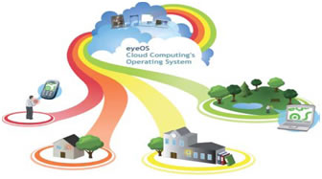  
Figure 4: Centering work and entertainment in a single place**

EyeOS is all about entering work and entertainment in a single place. EyeOS is about removing compatibility issues between applications and operating systems and taking your life everywhere. EyeOS is available in 30 translations. And is used privatively and professionally throughout the world rather it is used for public environments, schools, small and large companies alike or a way to share data with your family. EyeOS has a use in our digital life era.

**5.2. HISTORY**   
Establishment: In **2005**, a group of young people worked together and put all their efforts in a new project, a new open source web desktop, **EyeOS**.  
**August 1, 2005:** The first publicly available **EyeOS** version was released as **EyeOS** 0.6.0. At the time, it greatly participated in creating the definition of a web operating system and acted as a concept. Quickly, a worldwide community of developers took part in the project and helped improve it by translating, testing and developing it.  
**June 4, 2007:** After two years of development, the **EyeOS** Team published **EyeOS** 1.0. Compared with previous versions, **EyeOS** 1.0 introduced a complete reorganization of the code and some new web technologies, like eyeSoft, a portage-based web software installation system.   
**July 2, 2007:** With the release of the 1.1 version, **EyeOS** changed its license and migrated from GNU GPL Version 2 to Version 3.  
**October 29, 2007:** 1.2 version was launched with full integration compatibility with Microsoft Word files.  
**January 15, 2008:** **EyeOS** 1.5 Gala was liberated. The first version that supported both Microsoft Office and OpenOffice.org file formats for documents, presentations and spreadsheets. It also had the ability to import and export documents in both formats using server side scripting.  
**April 25, 2008:** **EyeOS** 1.6 included many improvements such as synchronization with local computers, drag and drop, a mobile version and more.  
**January 7, 2009:** **EyeOS** 1.8 Lars featured a completely rewritten file manager and a new sound API to develop media rich applications.  
**April 1, 2009:** 1.8.5 version incorporated a new default theme and some rewritten apps like the Word Processor and the Address Book.

**5.3. ARCHITECTURE OVERVIEW**

**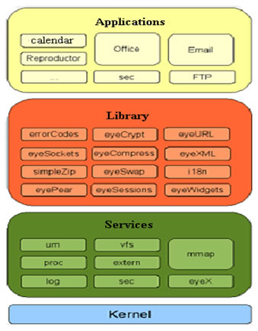  
Figure 5: Architecture overview of eyeOS**

EyeOS kernel uses a structure divided into 4 layers:

* Kernel: unified system services.
* Services: lower-level functions.
* library services: higher-level functions
* Applications: can call functions from any layer
* **Service MMAP**
* Vital component in the communications of the application.
* Route messages to the client application.
* Automated service.
* **Service VFS**
* It is the EyeOS file system.
* Implement security systems.
* Concatenate 32 random characters.
* Virtual and real functions.
* Provides application development.

Get the XML messages and respond in the same format to the browser

**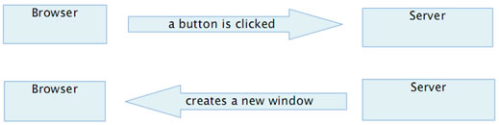  
Figure 6: Working of eyeOS in kernel**

Process Management:

* Launch.
* Finish.
* List.
* etc.

Process defines important variables for the application: myPid

* myPid: identifies every process.
* checksum: identifies the process in the client-server communication.
* **Client-server communication.**

EyeOS use a two-tier architecture in which one machine acts as both application and presentation server. The client is the second tier. The application server hosts virtual machines that run programs and push them to a presentation server, which manages the client connection. The thin client runs the application and passes user input back to the application server.

* **Client-side**

EyeOS makes use of several technologies on the client (browser) side:

* XHTML and CSS are used to display the user interface. The content, however, is created and changed dynamically by the local JavaScript engine, which uses the DOM for this task.
* The local engine handles communication with the server asynchronously, using AJAX. Client and server communicate via XML requests/responses. The client always initiates communication. Each server response specifies a series of tasks to the client engine (e.g. creating a widget, changing a value of a component, executing JavaScript code embedded in the message, etc.).
* Not all interactions require communication with the server. JavaScript is used to provide client-side-only interactions
* **Server-side**

Though it is not the focus of the project, we briefly comment on the server side of the architecture. EyeOS is written in PHP on the server side, and provides multiple high level abstractions. The goal of these is to make it easy to write new applications, and avoid dealing with low-level primitives. In this sense, EyeOS is also a web application development framework.

**5.4. What is a process inside eyeOS?**

Every time an application is executed, an entry in the process table of a user is created. This entry is an associative array that contains information about the name, Process ID (pid),checksum, try, current User (the name of the user who launched the process) and the time it was launched. In the default installation, the process table is a session variable named 'Process Table'. By default, an EyeOS application can have multiple instances of itself running flawlessly. Every instance has its own entry on the Process Table and has its own information separately from the others. Despite that behaviour, a programmer can make an application to avoid having multiple instances by looking up the name of the application in the process table.

**5.5. SECURITY**  
This service stands out primarily for its tight security, which has earned an average growth of 400 users per day. Some of its security measures involve the use of firewalls, backups every 24 hours total, and formatting a month as a preventive measure in case some are infiltrated by malicious code. As additional precaution, all communication is made within the site, and all content stored by users is fully encrypted and no access by their administrators, which gives an additional advantage in terms of use privacy.

**5.6. FEATURES**

* Being able to work from everywhere, regardless of whether or not you are using a full-featured, modern computer, a mobile gadget, or a completely obsolete PC.
* Sharing resources easily between different work centres at company, or working from different places and countries on the same projects.
* Always enjoying the same applications with the same open formats, and forgetting the usual compatibility problems between office suites and traditional operating systems.
* Being able to continue working if you have to leave your local computer or if it just crashes, without losing data or time: Just log in to your EyeOS from another place and continue working.
* A Web OS runs on any Internet enabled computer or device. This is important for mobile workers or people who don’t have their own computers and must work out of Internet cafes, libraries, or schools.
* Web OS users can work, log out, and then log in later from a different computer.
* Web OS can run on different computers, the technology facilitates collaboration among multiple work centres. The traditional OS runs on only one computer.
* Extensions such as the Network File System a way for different machines to import and export local files and remote desktop a way to control one computer by using another device allow easier access to information from multiple locations and better user collaboration.
* With a Web OS, users can store, find, and otherwise manage files and services, such as calendars and email, from a Web desktop.
* Storing applications, files, and services on OS provider’s servers, rather than on the user’s computer, make them harder for a PC or laptop thief to use.
* Web OS users don’t have to back up or archive work because the providers remote server handles these functions.
* The technology also promises to reduce users? long-term computer and device costs because much of the heavy processing is concentrated in providers Remote servers, Sun’s Web OS operates across platforms, it eliminates compatibility issues between applications and operating systems. Thus, the same Web OS will run on a Windows, Mac, or Linux machine.
* Application developers create an application only once for a Web OS, rather than many times for each of the traditional operating systems. And system administrators have to deploy an application only once for a given Web OS.
* They can then easily distribute it online to users. Because the Web OS and its applications are generally based in servers that can be monitored and secured from one location, they provide centralized malware protection.

**5.7. MARKET VIEW**  
The idea behind EyeOS is that the whole system lives in the web browser. The client must have only a web browser to work with EyeOS and all its applications, including Office and PIM ones. This applies to for both modern and obsolete PC’s.  
There are no license costs with EyeOS: It’s Free, Open Source Software. Special programming, Support & Maintenance up to 24x7, Training and adaptation are offered as professional services. EyeOS work with private and public companies that are looking for an internal intranet: big companies that would like to offer a virtual desktop to their customers, small and big administrations, and the education world EyeOS for Education.   
Free Internet Access Points Resources Management Internet & Access Providers Servers Management EyeOS Mobile Professional Meetings Manager Available Services. These are the projects that have under consideration and working effectively by keeping in mind to give the best cloud service. The free public server for everyone that has already reached 4,00,000 users.  
EyeOS provides Support Packs for both Open Source and Commercial Edition customers. Whether you are trying EyeOS for the first time or deploying a mission-critical application, we have a plan that meets your needs and budget.  
Who would like to have a full EyeOS environment with more space, more allowed upload max file size, the ability of managing users and groups and installing new applications there hasn?t been an officially offered option before.  
We’re today starting tooffer full EyeOS servers, with the following specs:

* From 5 GB to 40 GBof space
* Unlimited number of users
* EyeOS bundled with everything necessary to run inside. The specs and configurations have been prepared by the EyeOS Team.
* Office support enabled and working from the first moment. There is a separatedserver (outside the EyeOS servers) only for Office, so the office files conversion is specially fast even in the smallest servers, since it’s done in a much more powerful server inside the network.
* A maximum upload file sized of 1000 MB (you can basically upload almost every file you want to your EyeOS and keep it online, directly with eyeUpload or through eyeSync for Windows, Mac and Linux).
* Every single server is inside a Virtualized Private Server environment: Your data will be safe and protected against others access.
* You will have the root account inside your EyeOS Server: This means being able to install new applications, creating work groups, enabling or disabling the possibility to allow people to create accounts, assigning a maximum space quota per every user.

**5.8. ADVANTAGES**

* Portability,
* Decentralization,
* Availability.

**5.9. DISADVANTAGES**

* Safety,
* Need for fast connection performance,
* Isolation of the host system.

**5.10. APPLICATION DOMAIN**

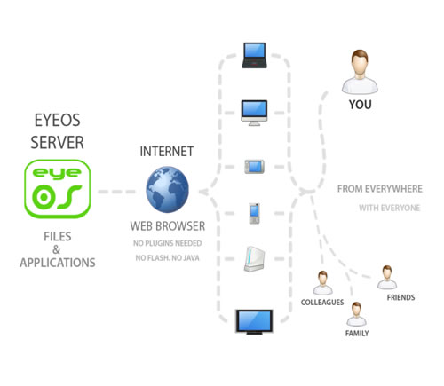

**Figure 7: Application domains**

* EyeOS provides system for the users where they work with EyeOS and all its applications, including Office and PIM ones. EyeOS provides a toolkit to create new applications easily.
* EyeOS can provide schools and universities with a full web platform where students, teachers and parents will have a personal yet collaborative desktop to work and, communicate between themselves and get organized inside and outside the school.
* With a private server, EyeOS can provide city councils, public library networks, free Internet points and other public environments the perfect system for their users to have a web place to work and communicate with the network managers, registering once and using it from every point.
* One of the main triggers and great acceptance of people with regard to this service is its availability online, which has no dependencies and has a strong security system, achieving thus be an ideal application for storing content. This action may be useful for those who travel frequently, for schools that want a centralized storage and available for intranets and business in general and so on.; Even could be used in any future as a service to replace the need for a hard disk

**Among the most typical uses are highlighted**

* Schools: There is a Web system that brings a personal space for each teacher and student, which can be leveraged to work collaboratively. Also it is best accessed from anywhere you have Internet access.
* Public places may be in libraries or on points that have open WiFi, allowing users to connect to have the same meeting place on the Web. Social Organizations and Companies: Contacts, personal files and communications to which members can access businesses and organizations large and small.

**5.11. FUTURE SCOPE**

**EyeOS 2.0 for developers**

EyeOS 2.0 is a development framework for creating RIAs quickly and easily. It has been fully developed using open technology and widely accepted standards, such as PHP, MySQL, javascript, qooxdoo, log4php, phpunit, OpenOffice and others, allowing the system to work on a common web server without any modification, and any standard browser, without needing to install additional plugins.  
EyeOS 2.0 is much faster than EyeOS 1.x, since it gives much more prominence to JavaScript. We have completely eliminated the PHP code which is not used for business logic. As a result, the client needs to make fewer requests to the server, and makes them only when needs persistence of data or specific business logic.  
EyeOS 2.0 has also added a cache system on the client side to eliminate server requests, even when these are for data persistence. The logical architecture of the system remains very similar to EyeOS 1.x, however, everything has been rewritten from scratch using design patterns with object-oriented programming, where for example, each system service kernel singleton component.

**Chapter 6**

**My Project Screenshot**

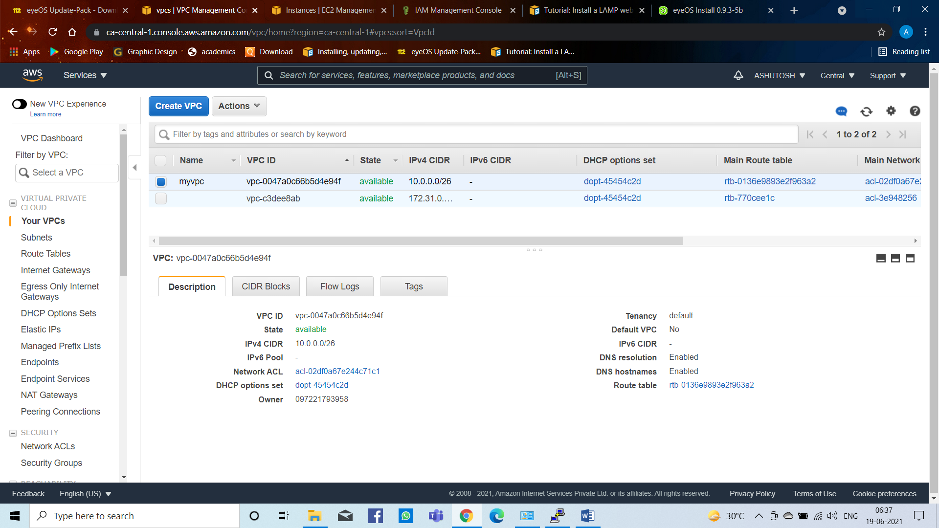

**Figure 8: Create VPC**

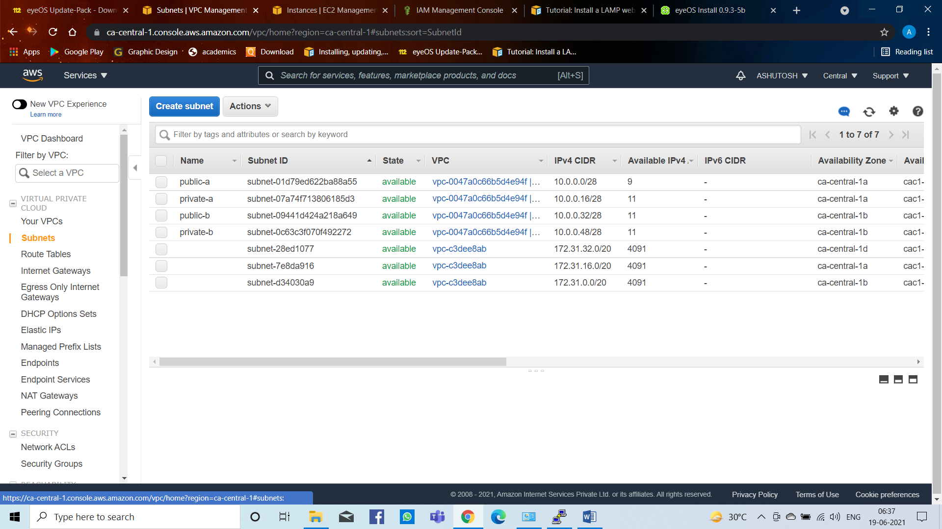

**Figure 9: Create Subnets**

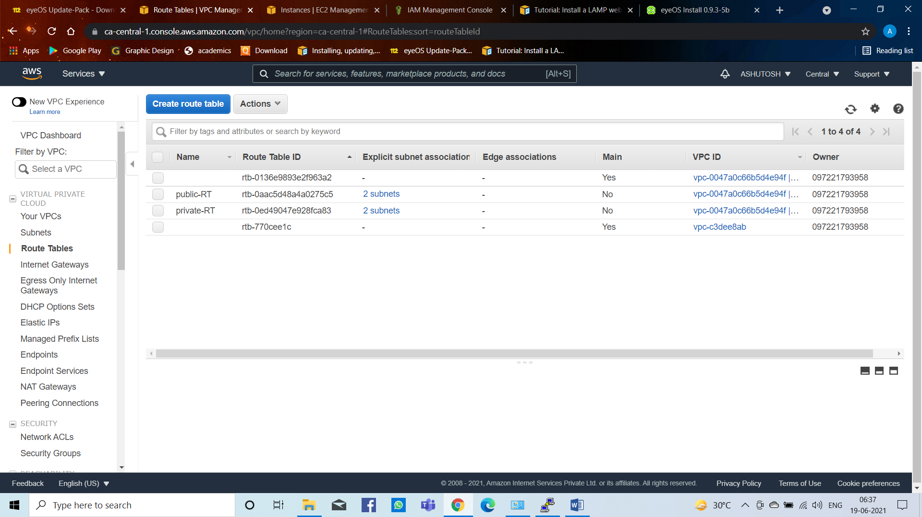

**Figure 10: Create Route Tables**

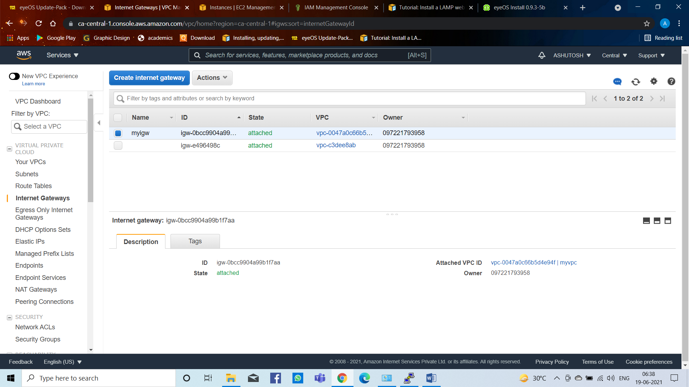

**Figure 11: Create Internet Gateway**

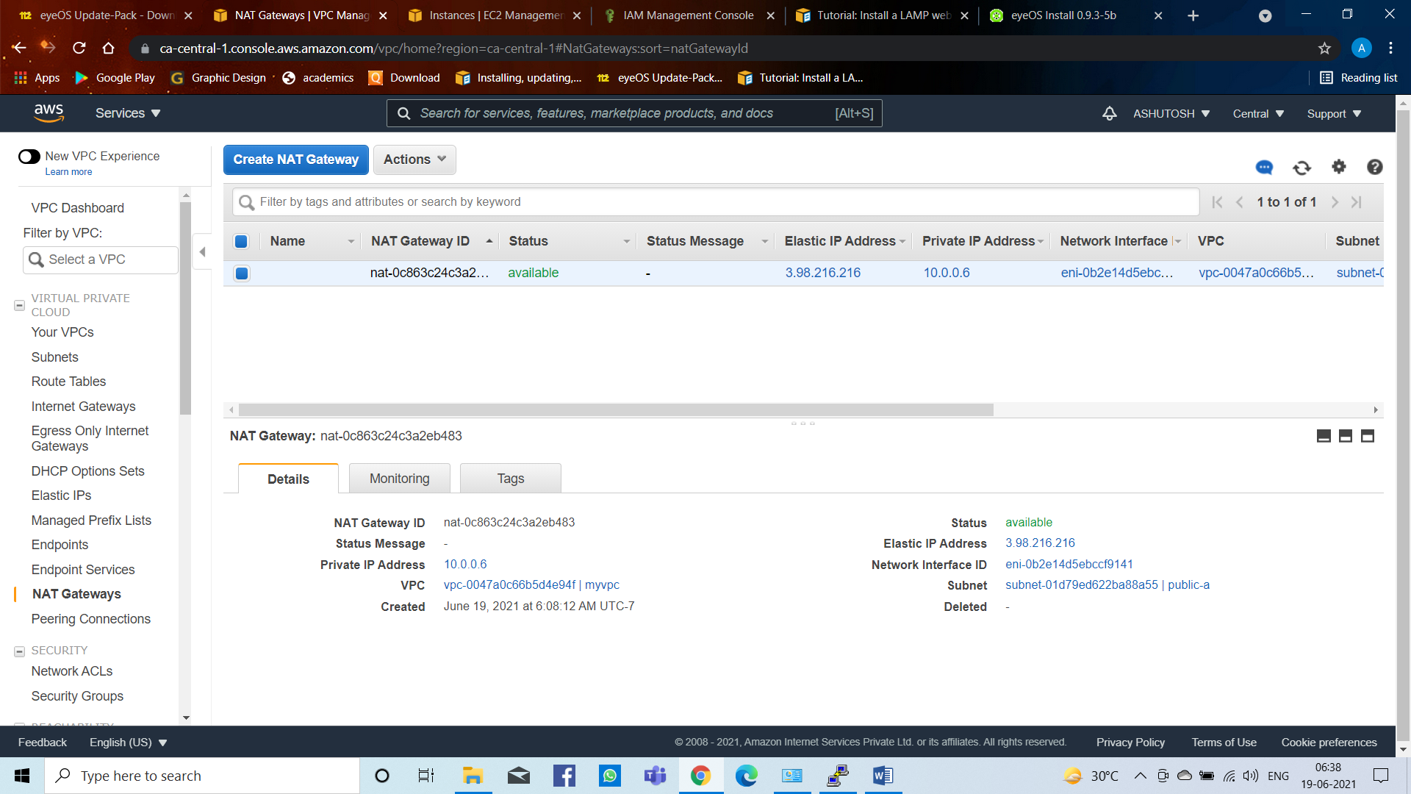

**Figure 12: Create NAT Gateway**

**IAM**

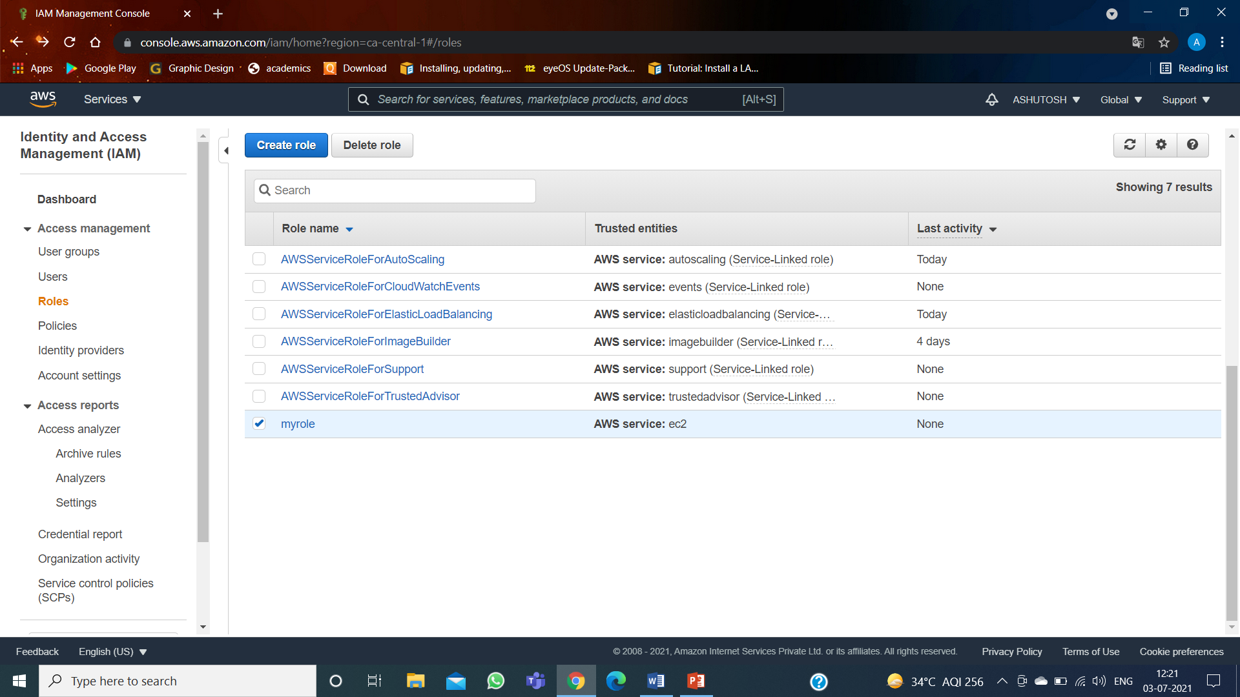

**Figure 13:** Create IAM Role

**S3**

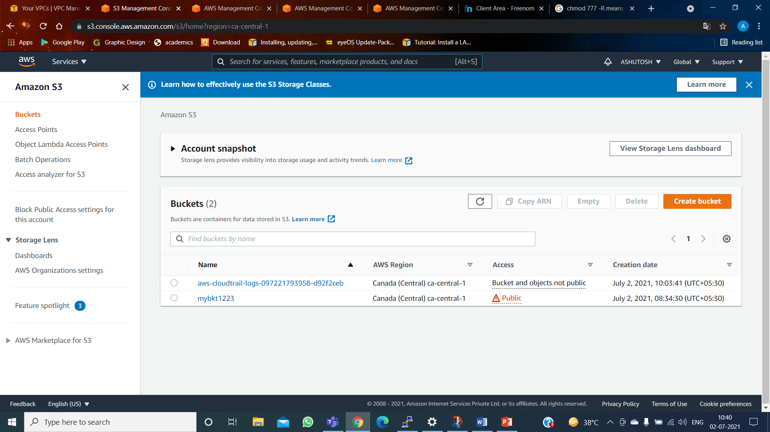

**Figure 14:** Create S3

**EC2 INSTANCES**

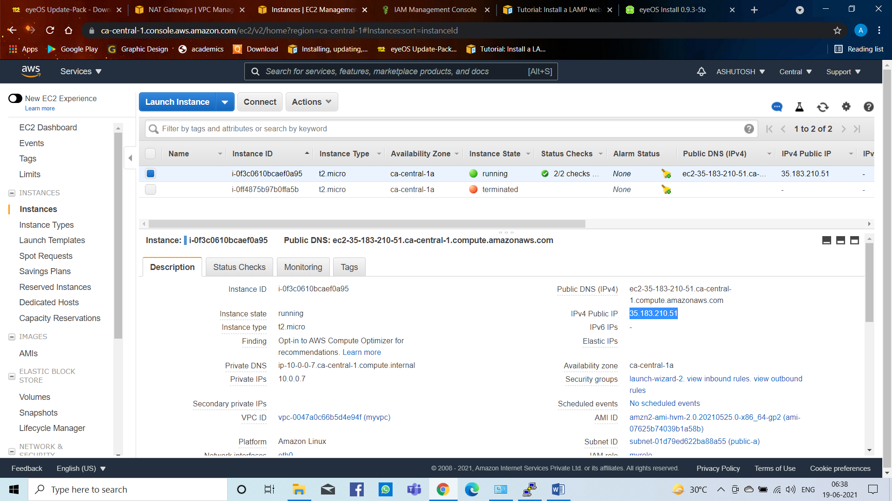

**Figure 15: Create EC2 Instances**

After creating EC2 Instance installing https and php driver and installing in server with putty software

And EyeOS Project installed in the server with putty

All the commands given below:[21]

1. sudo yum update –y
2. sudo amazon-linux-extras install -y lamp-mariadb10.2-php7.2 php7.2
3. sudo yum install -y httpd mariadb-server
4. sudo systemctl start httpd
5. sudo systemctl enable httpd
6. sudo systemctl start mariadb
7. sudo systemctl enable mariadb
8. aws configure
9. aws s3 cp s3://mybkt1223/eyeOS-UP-0.9.3-5e.tar.gz .
10. ls
11. tar –xvzf eyeOS-UP-0.9.3-5e.tar.gz
12. ls eyeOS-UP-0.9.3-5e
13. cd eyeOS-UP-0.9.3-5e
14. ls
15. sudo mv * /var/www/html/

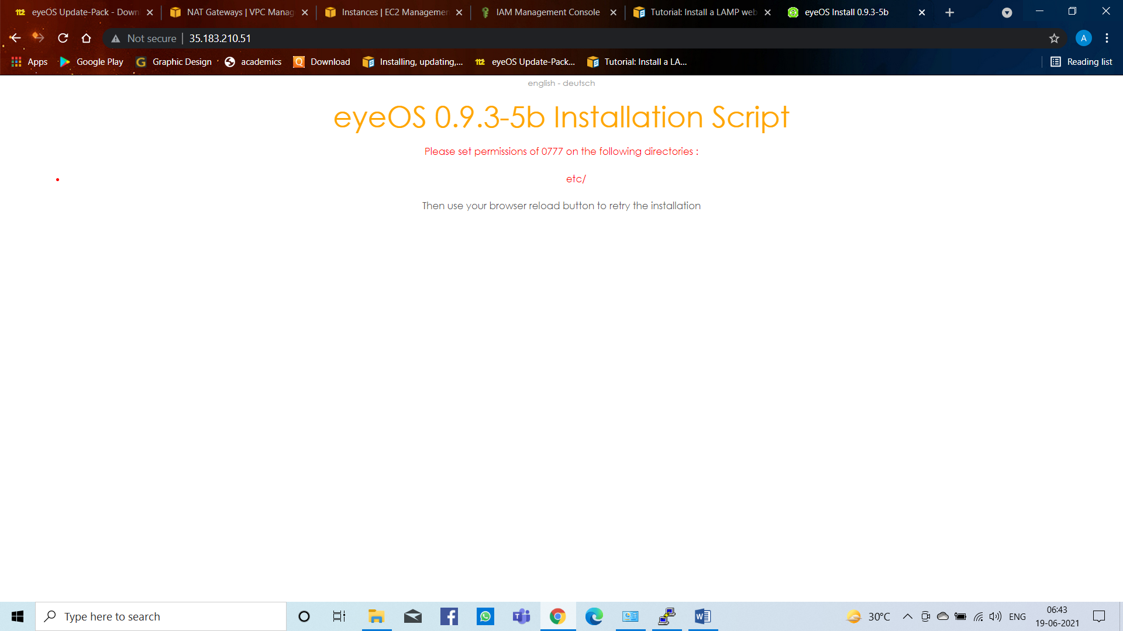

**Figure 16: EyeOS Project running on server**

Now set permissions of 0777 on the following directories: /etc

Now the commands

1. cd /var/www/html/
2. ls etc/
3. sudo chmod 777 –R etc/

After login we get

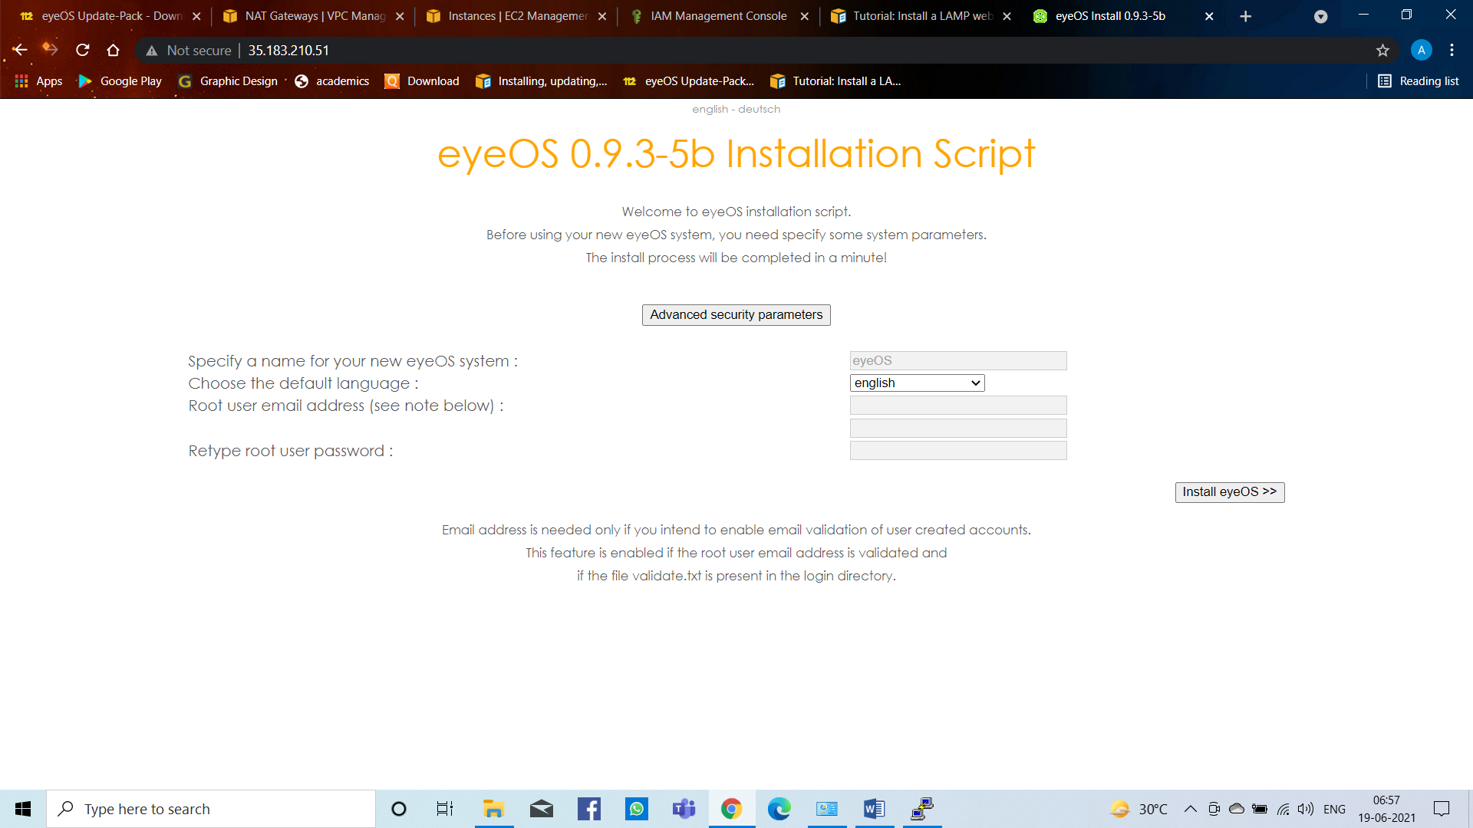

**Figure 17: eyeOS Installation**

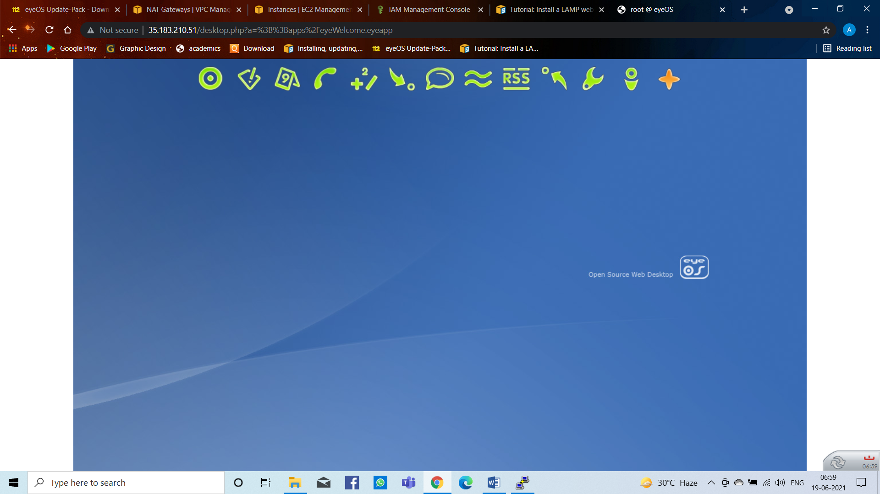

**Figure 18: After Installation**

**Now for domain we will use freenom.com site to register for domain for the website**

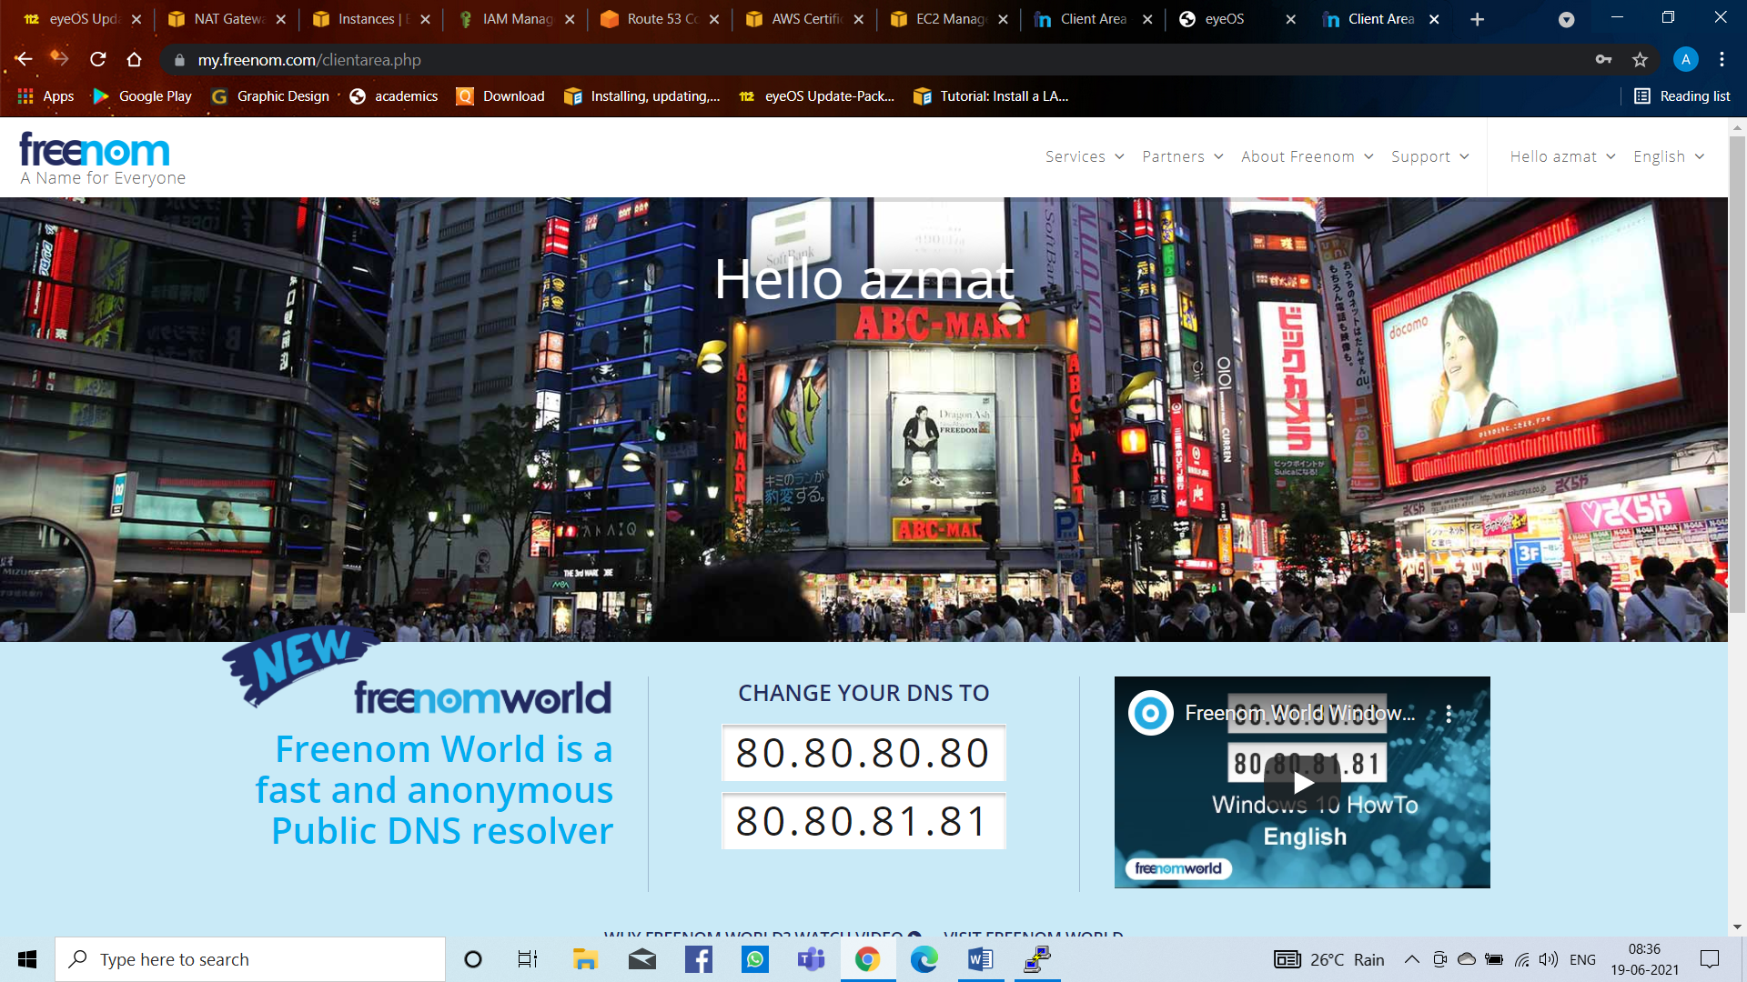

**Figure 19: Freenom Website for Domain[23]**

By this we will take domain for the website to run in the server.

After this we need to request for ACM Certificate and after create we get,

**ACM Certificate**

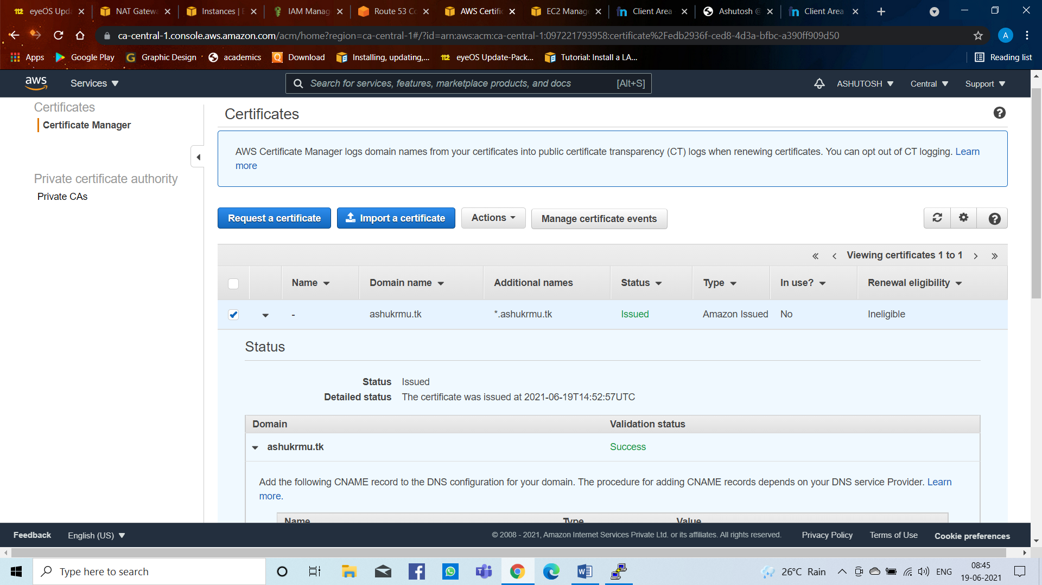

**Figure 20: Create ACM Certificate**

**Route 53**

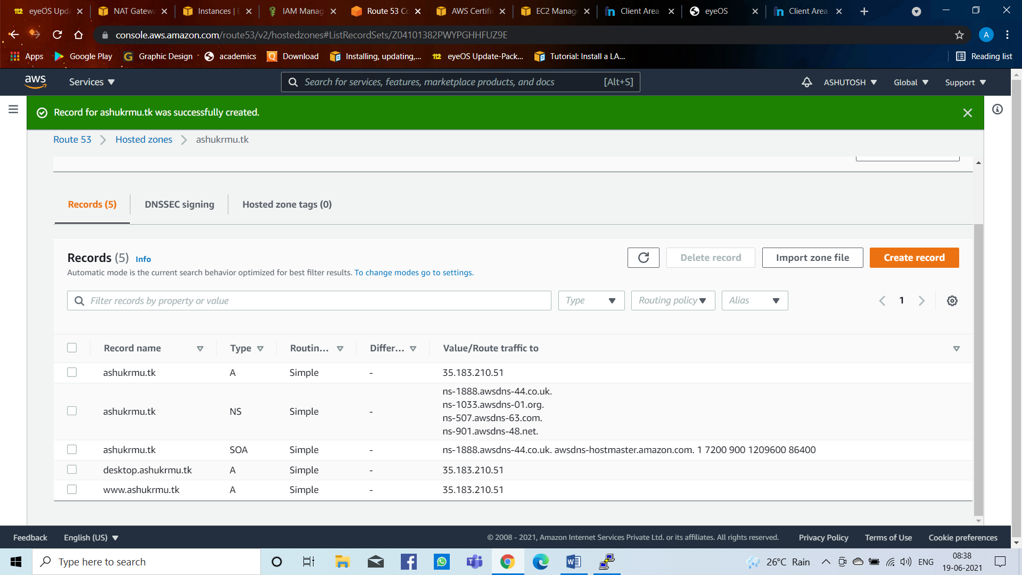

**Figure 21: Create Route 53**

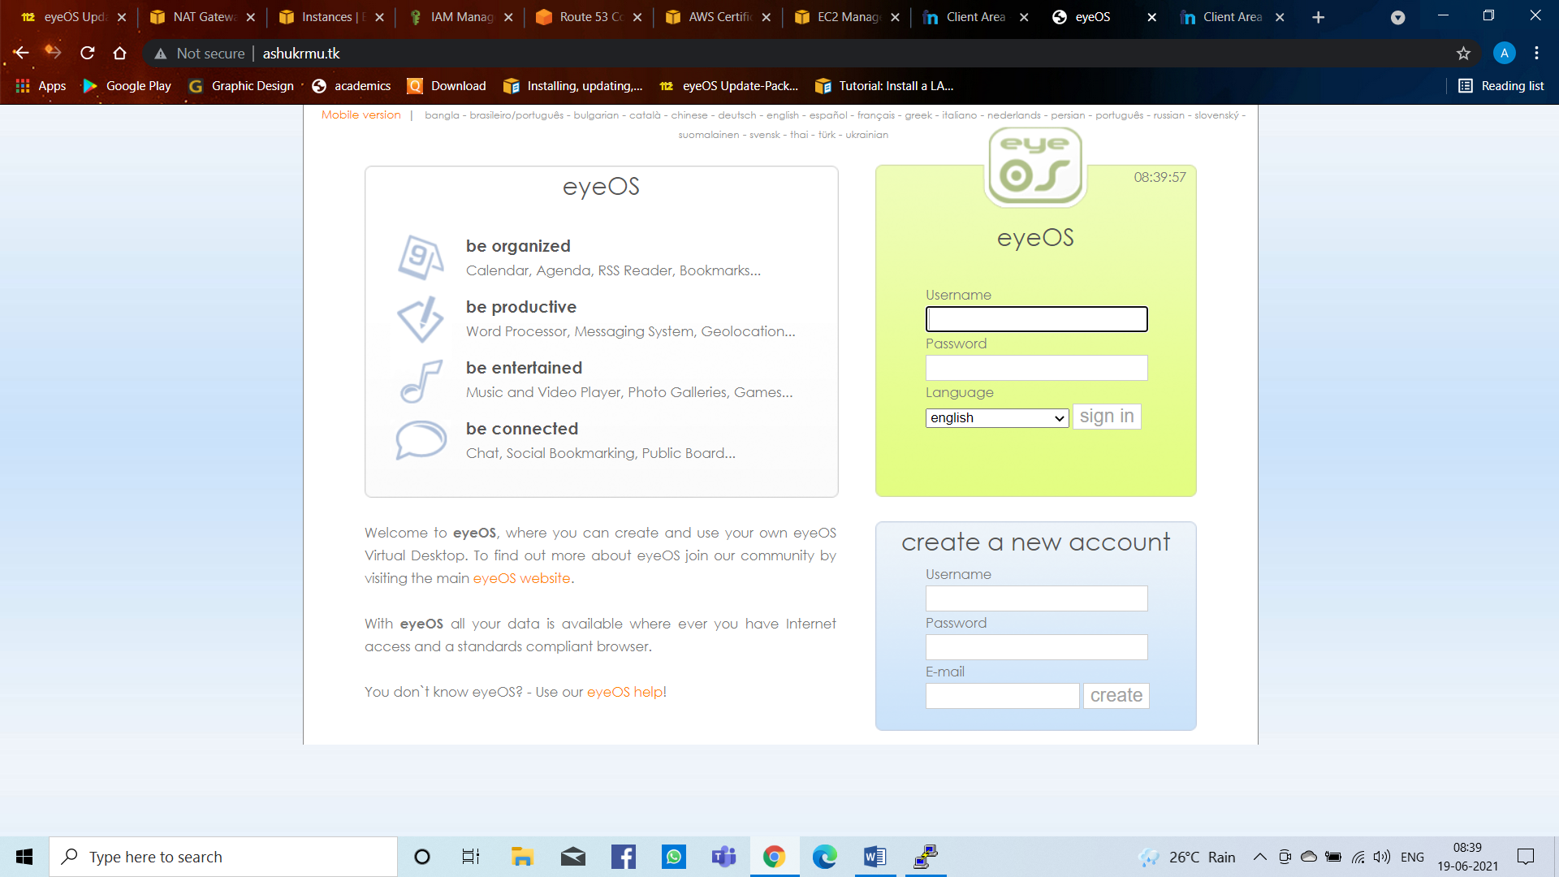

**Figure 22: EyeOS Project running with Domain on server**

**By creating a new account we get**

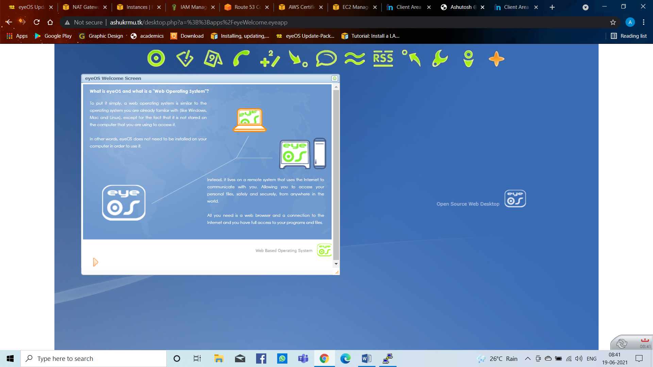

**Figure 23: After login eyeOS project**

Now to get site secure i.e. https we use Elastic Load Balancer by using classical load balancer

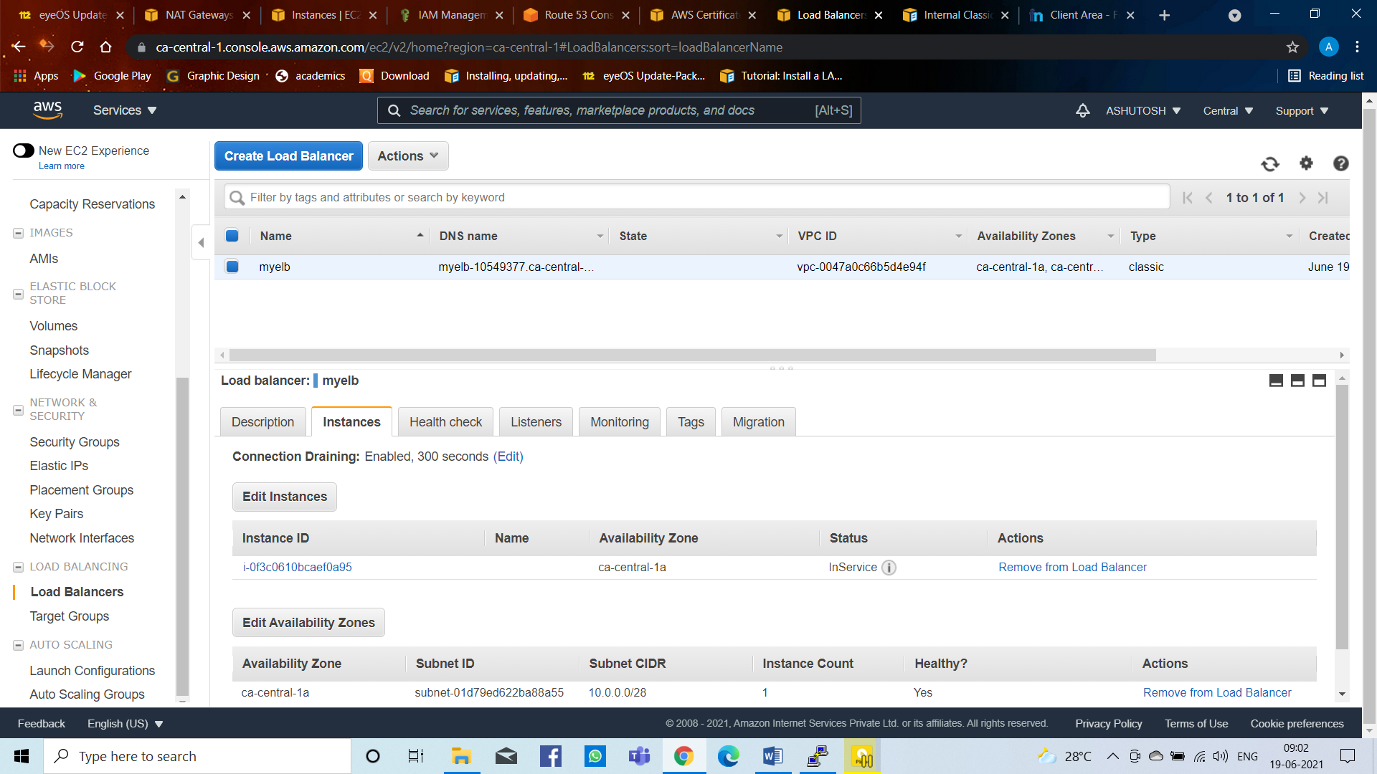

**Figure 24: Create Elastic Load Balancer**

With load balancer DNS name we open this site

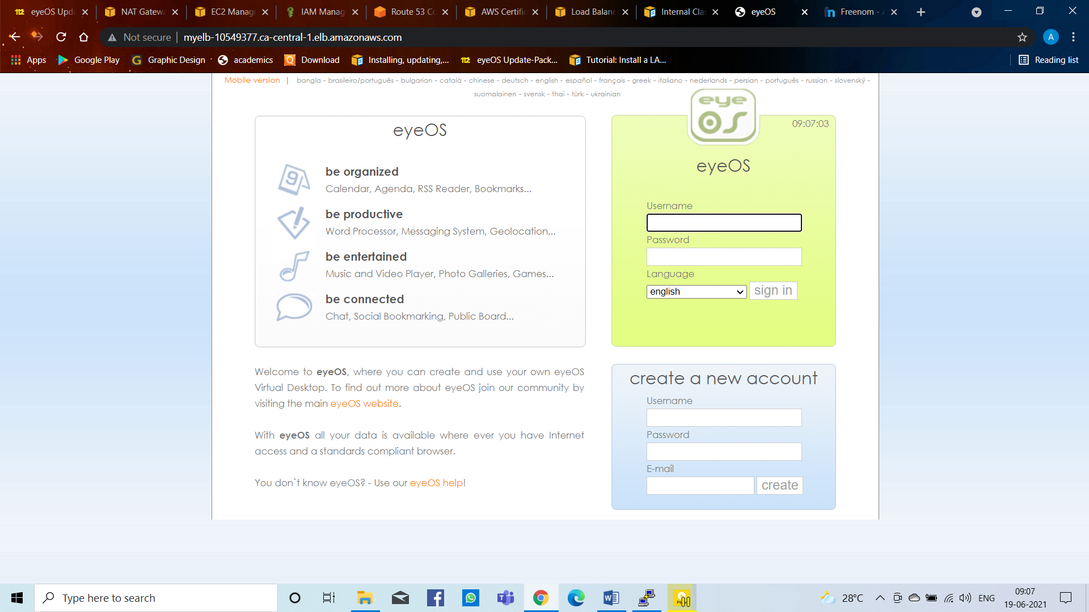

**Figure 25: Open with Load Balancer Domain Name**

Now after this we need to make changes in Route 53. Deleting all the record and making a new record with simple routing and attaching a classical load balancer with it.

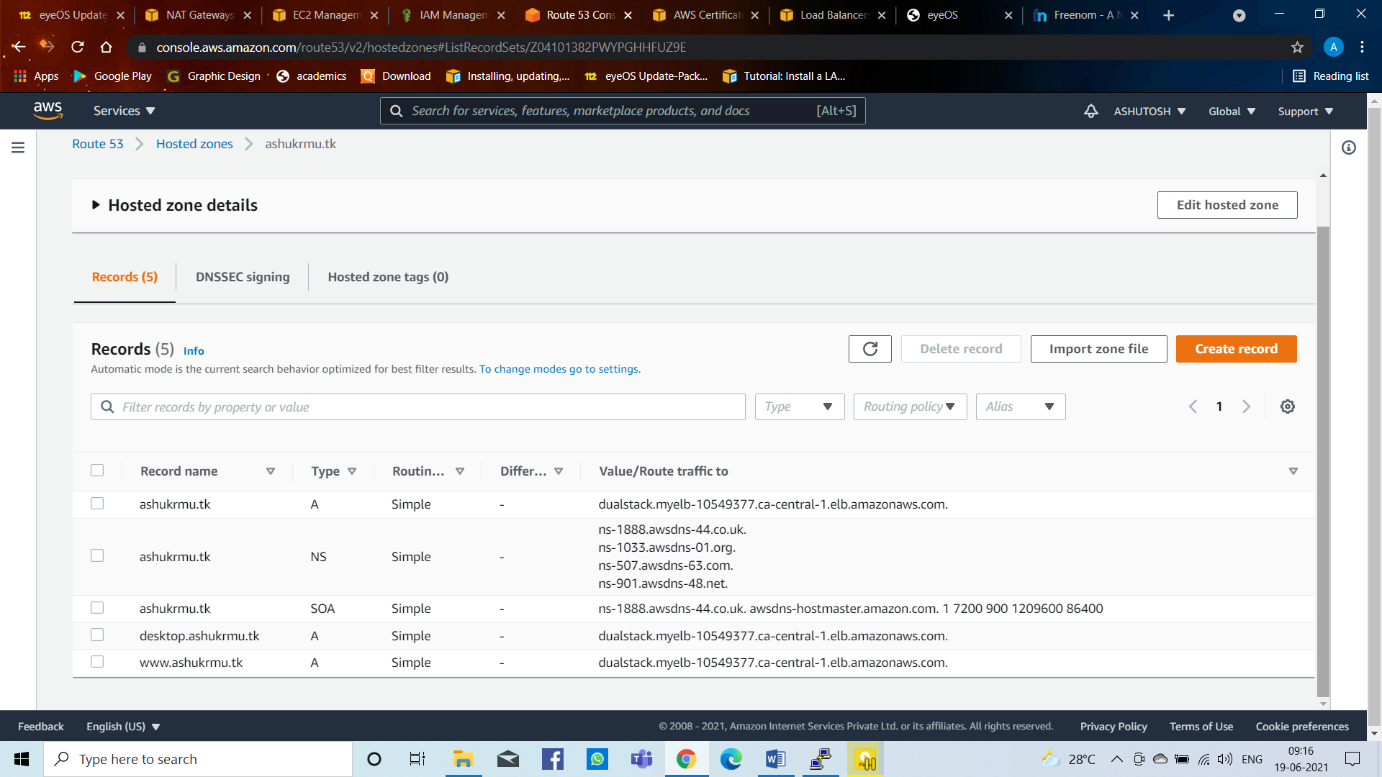

**Figure 26: Delete and Create New Record with Simple Routing with Route 53 (Attached with Load Balancer)**

Now the site has been secure with https

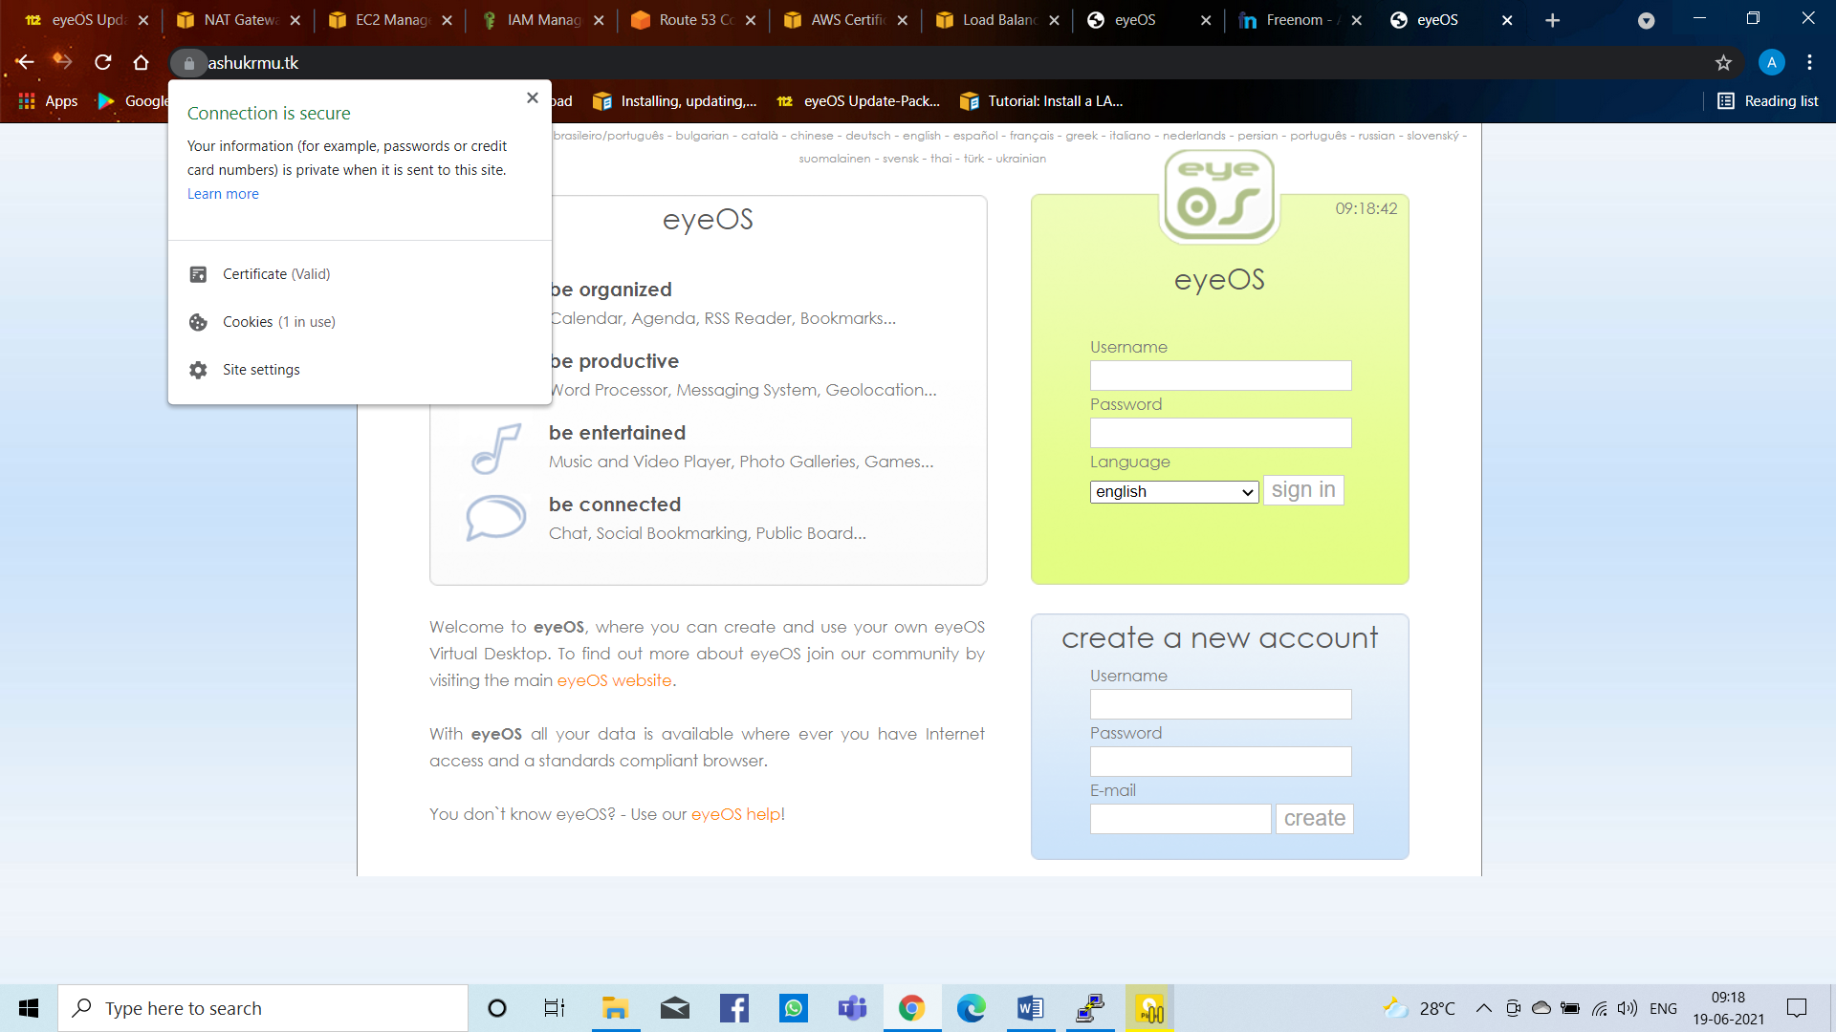

**Figure 27: EyeOS Project Secure with HTTPS**

Now we use Auto Scaling for (if 1 server fails another server automatically create and start the server with an AMI) automatic start new machine if one machine stops.

Before this we need to create AMI for Launch Configurations in Auto Scaling

**AMI**

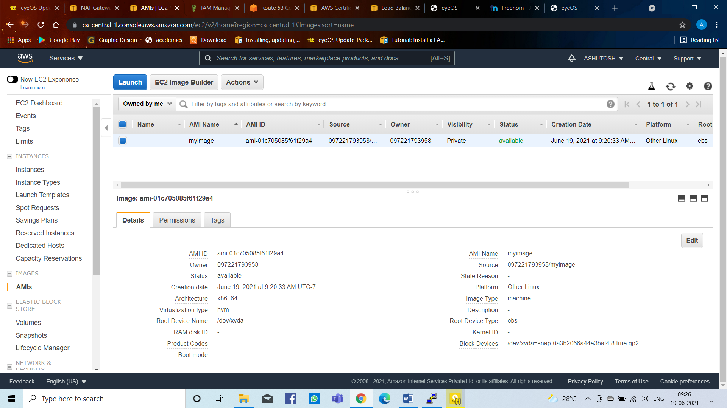

**Figure 28: Create AMI**

**Launch Configurations**

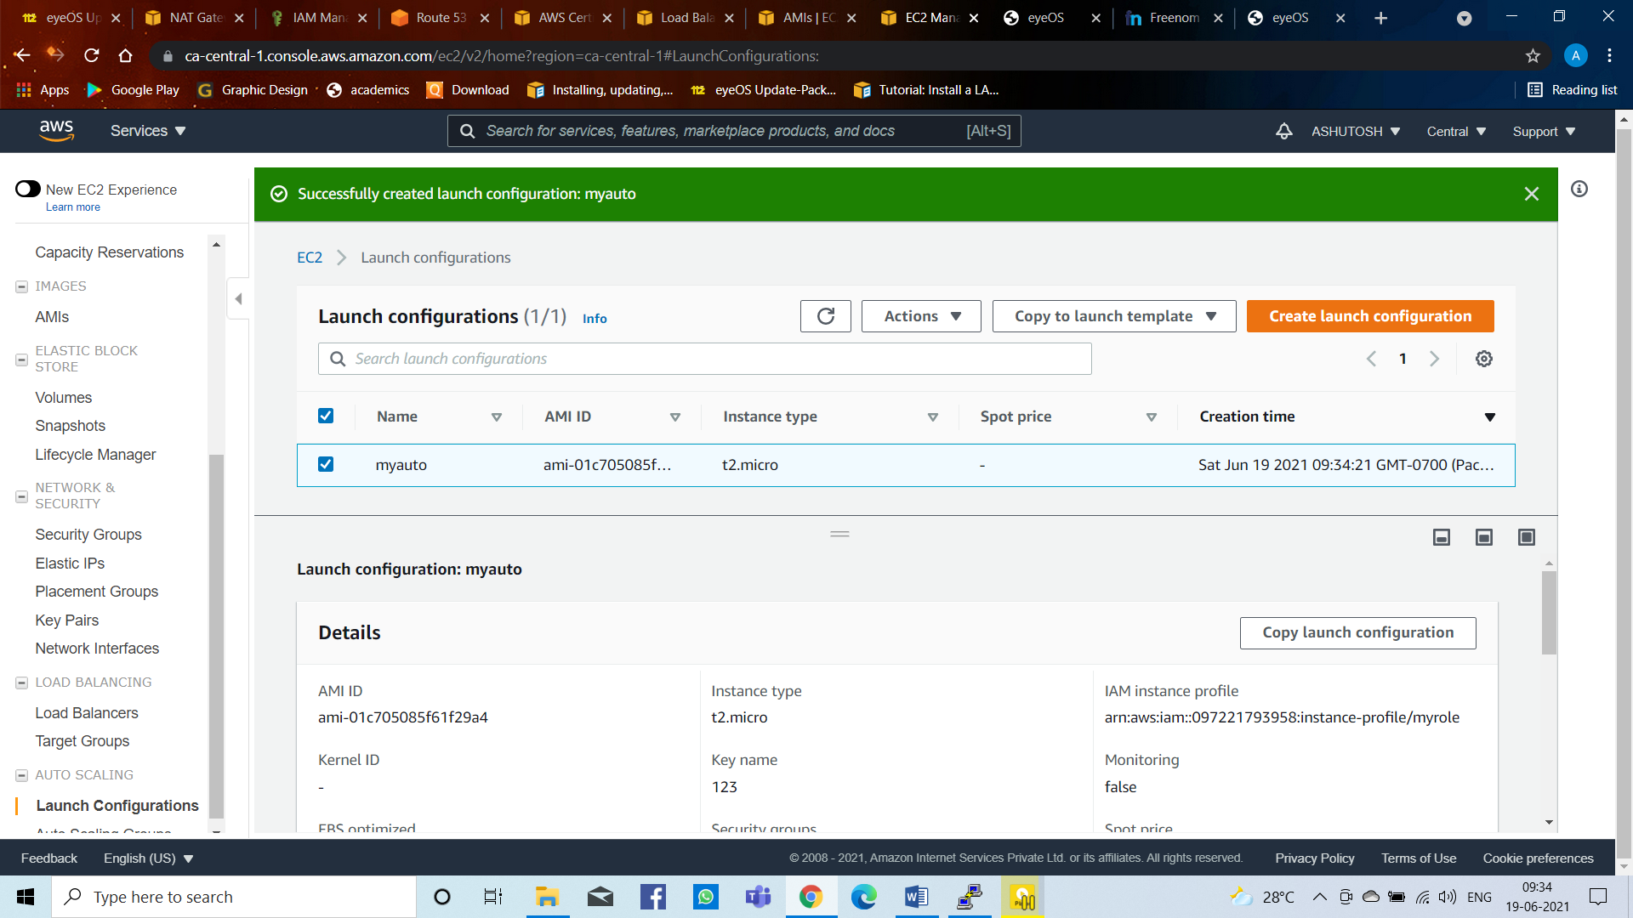

**Figure 29: Create Launch Configurations**

**Auto Scaling Group**

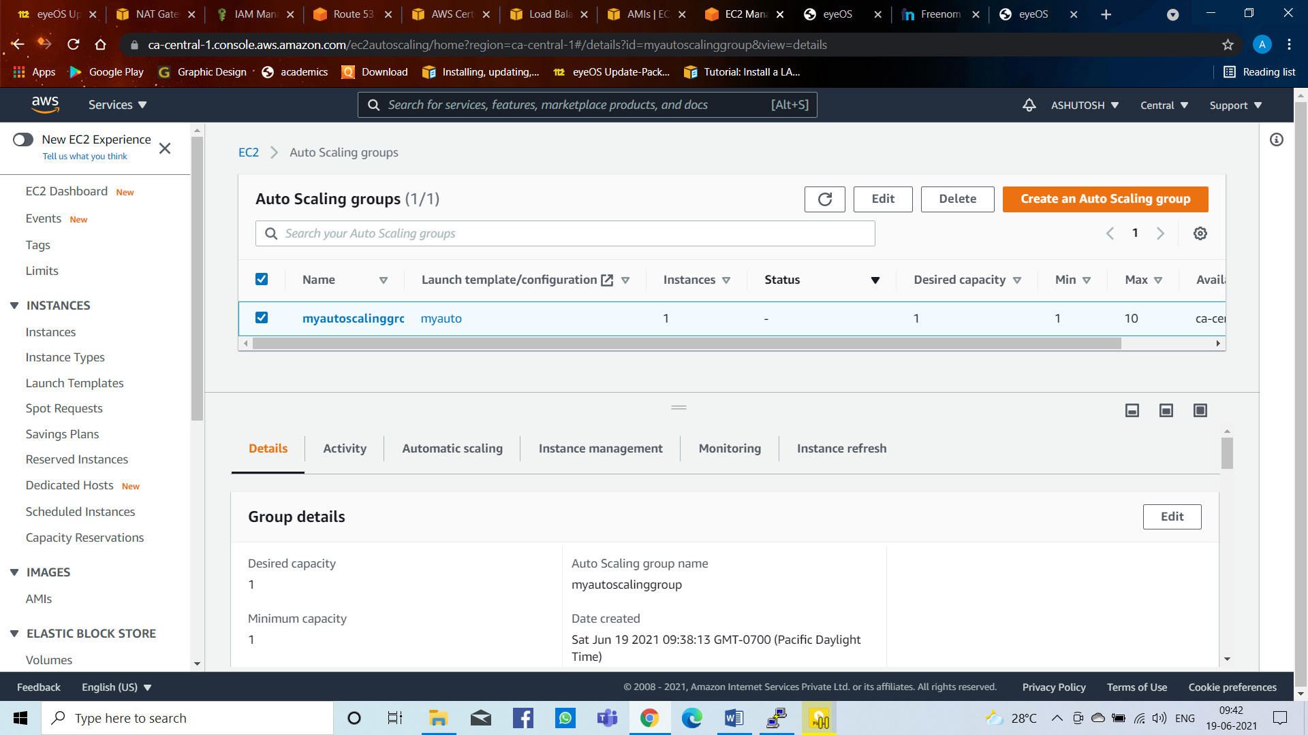

**Figure 30: Create Auto Scaling Group**

After this I use CloudFront is a fast content delivery network (CDN) service that securely delivers data, videos, applications, and APIs to customers globally with low latency, high transfer speeds, all within a developer-friendly environment.

**CloudFront**

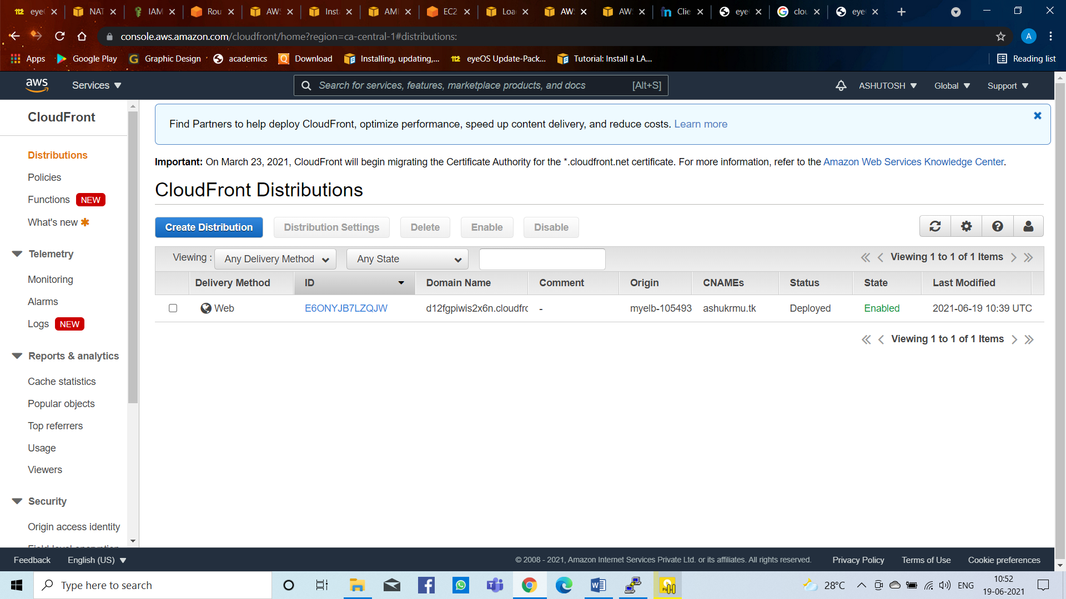

**Figure 31: Create Cloudfront**

After this I have done changes in Route 53 deleted all the quick start record and attached with cloudfront in Route 53

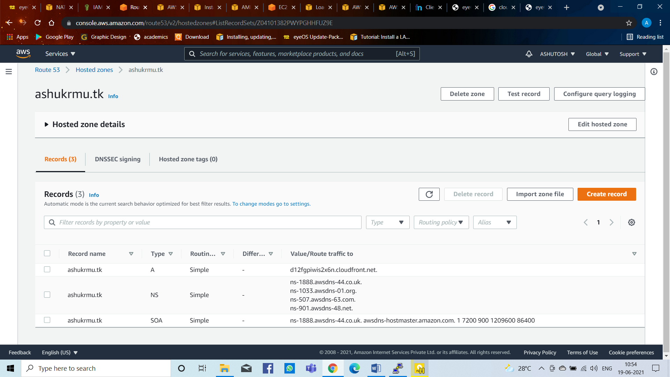

**Figure 32: Deleting all the record and making a new record attached with Cloudfront in Route 53**

Opened with Cloudfront domain name

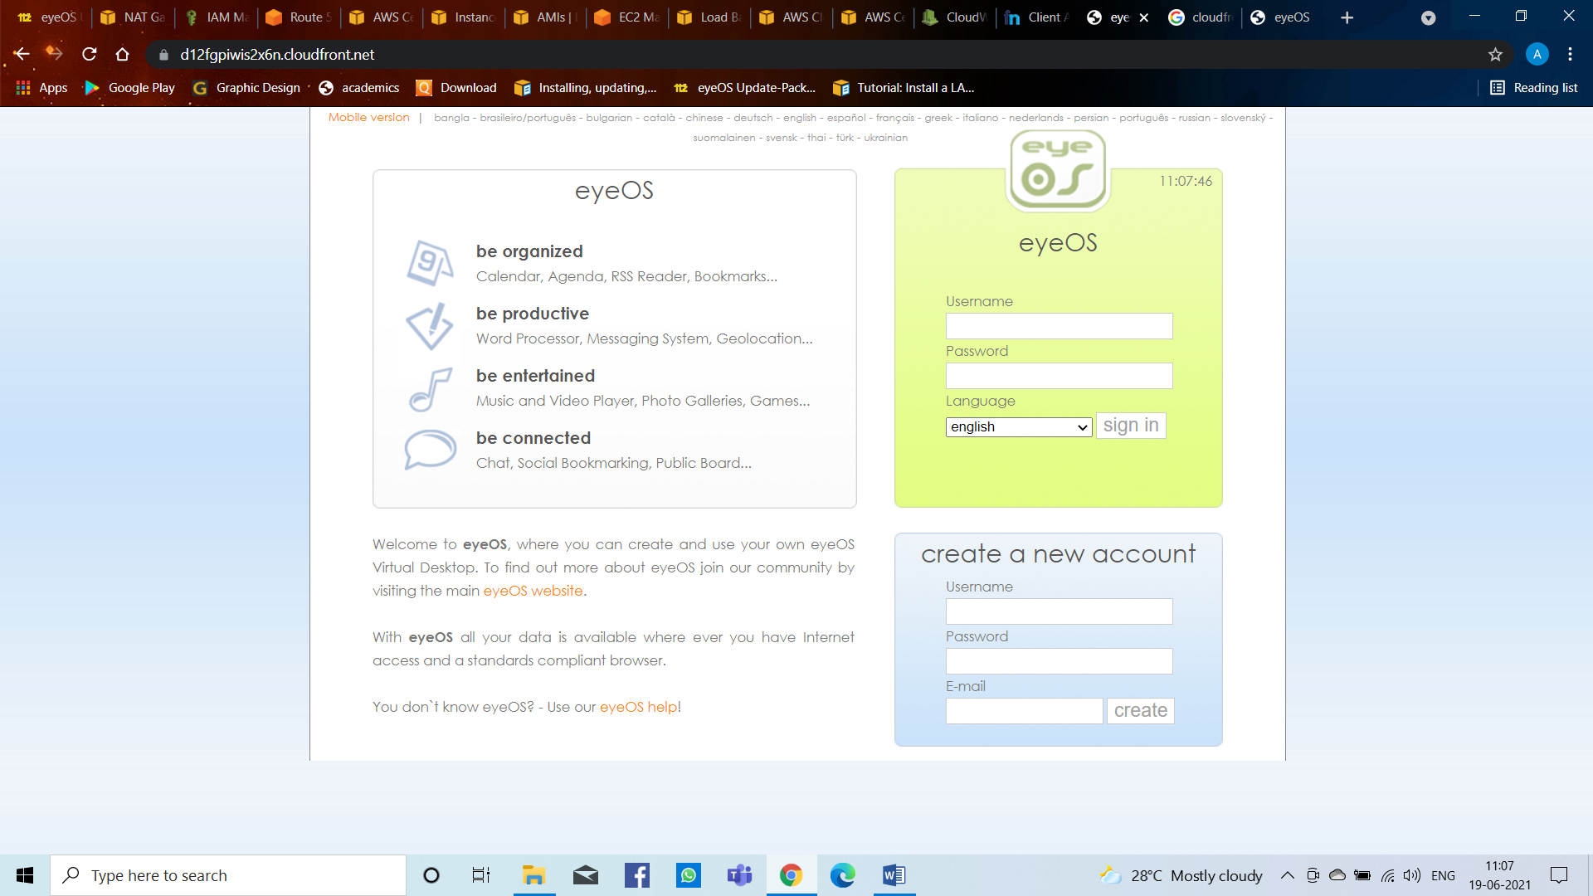

**Figure 33: Opened with Cloudfront Domain Name**

**CloudWatch**

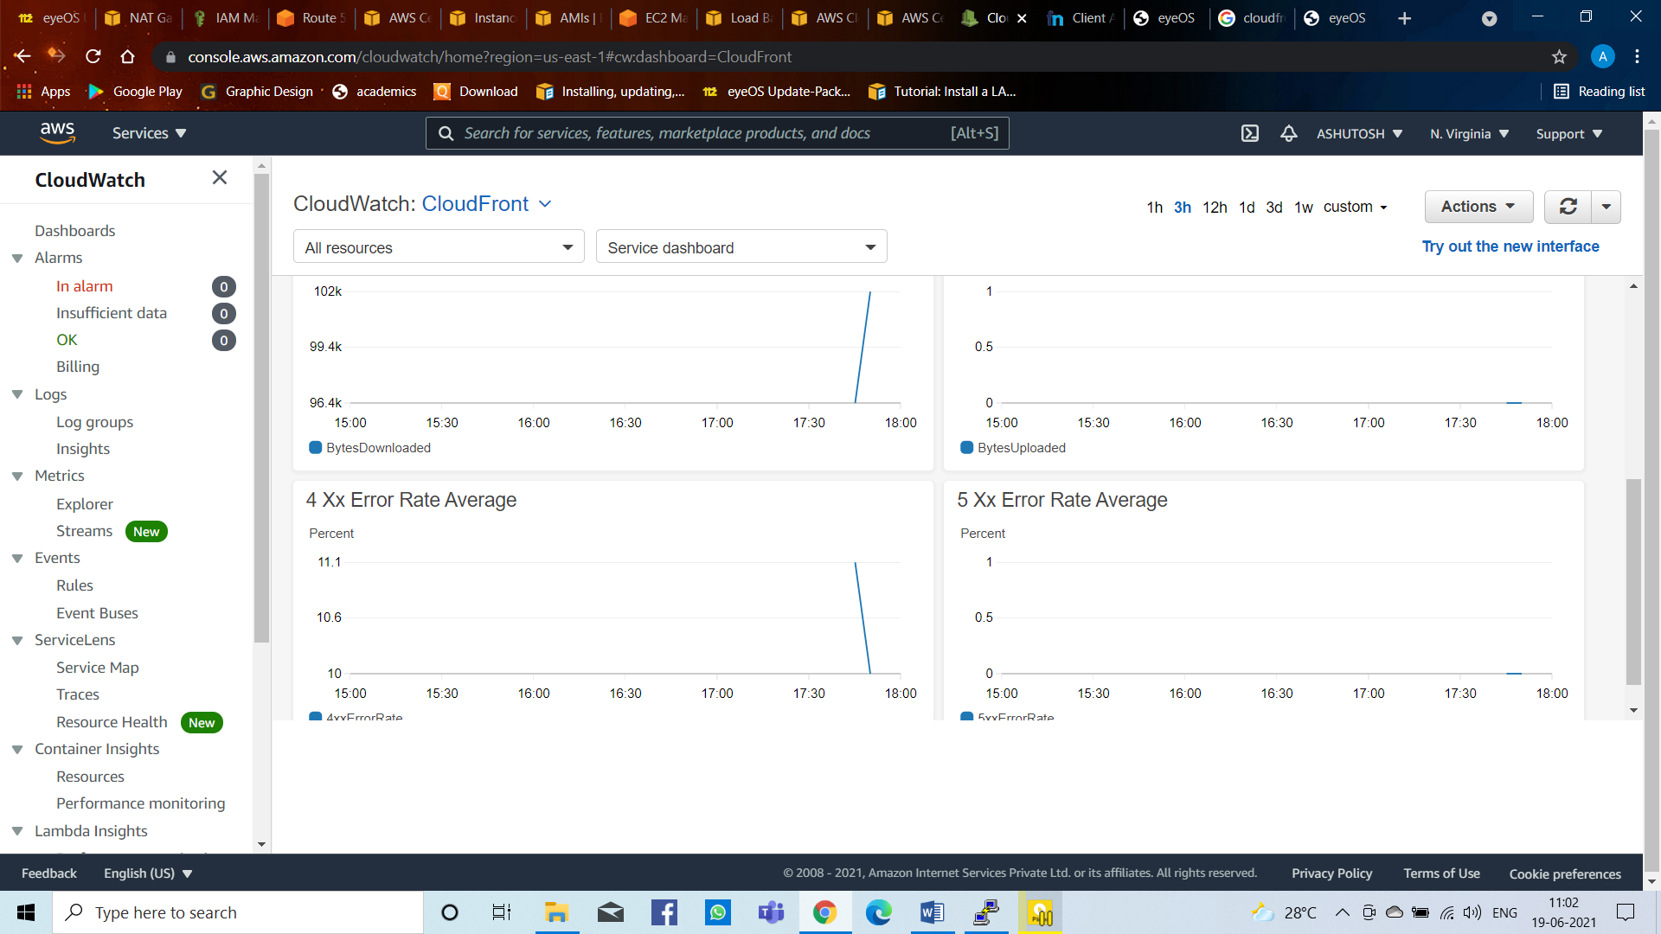

**Figure 34: Create CloudWatch**

**SNS**

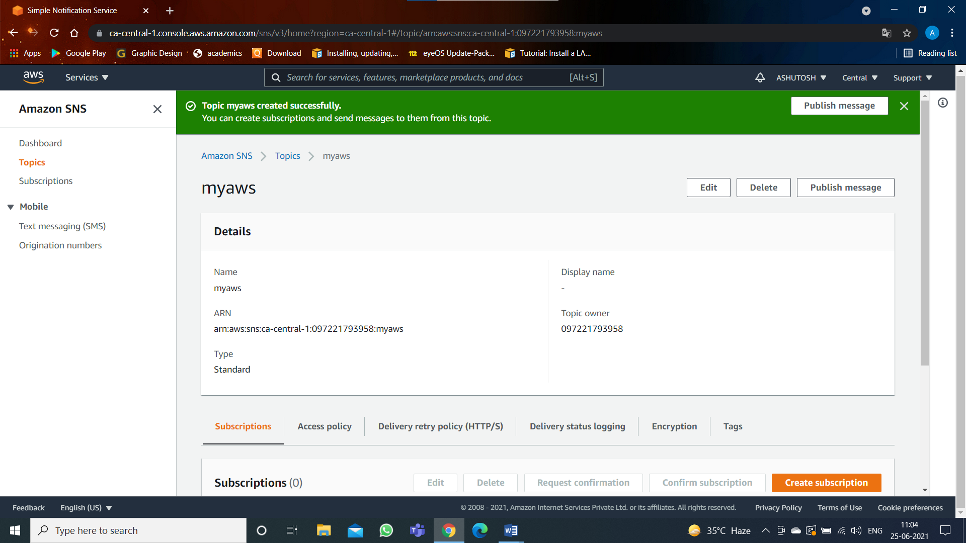

**Figure 35: SNS Topic**

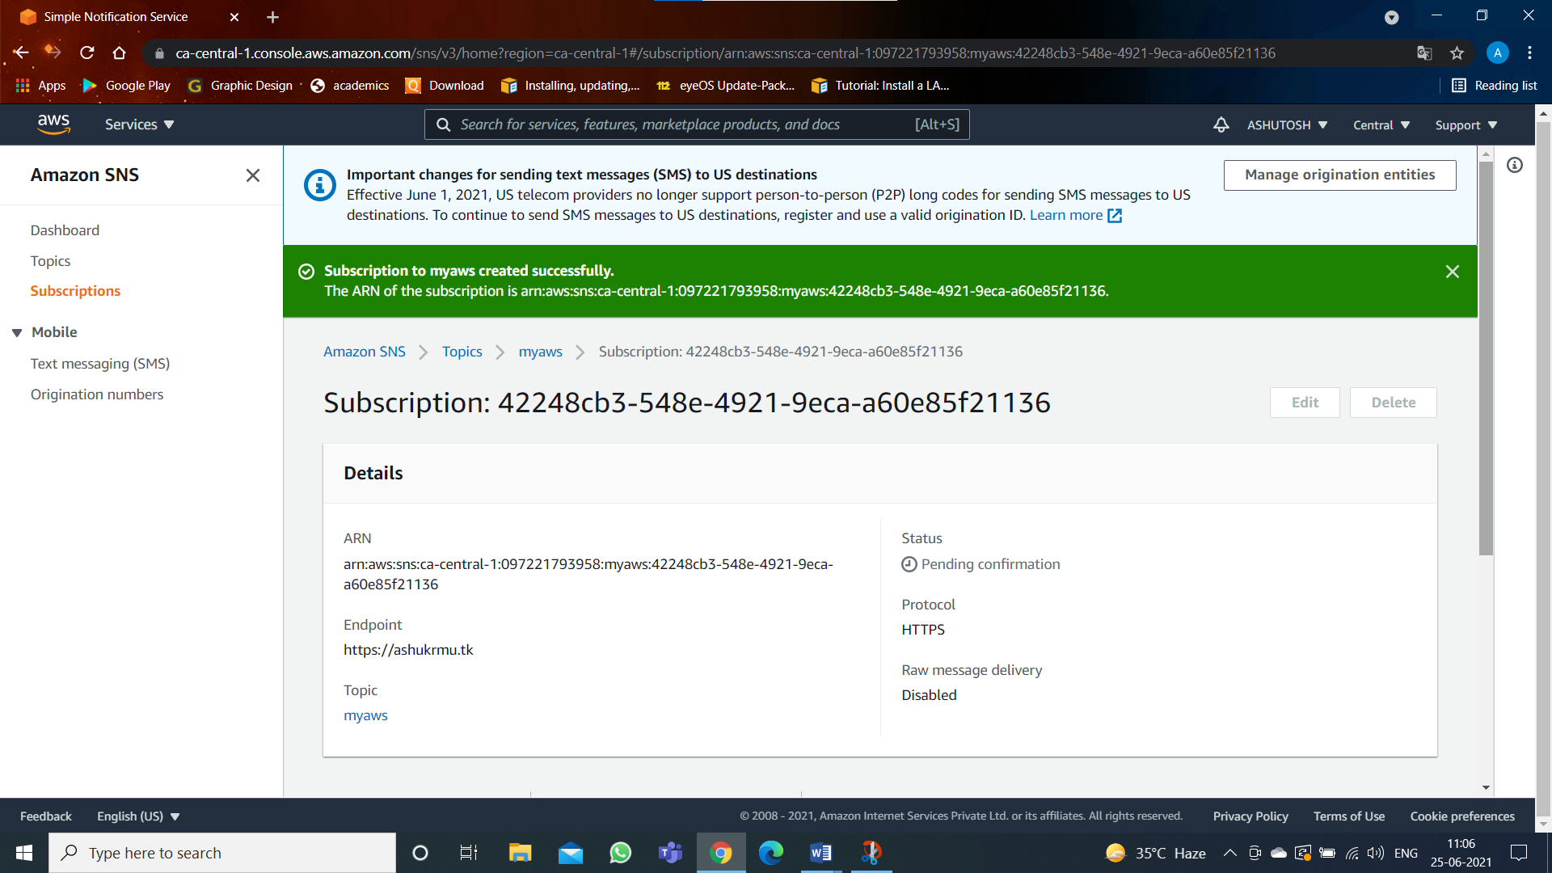

**Figure 36: Create SNS Subscription**

**Create Cloudtrail**

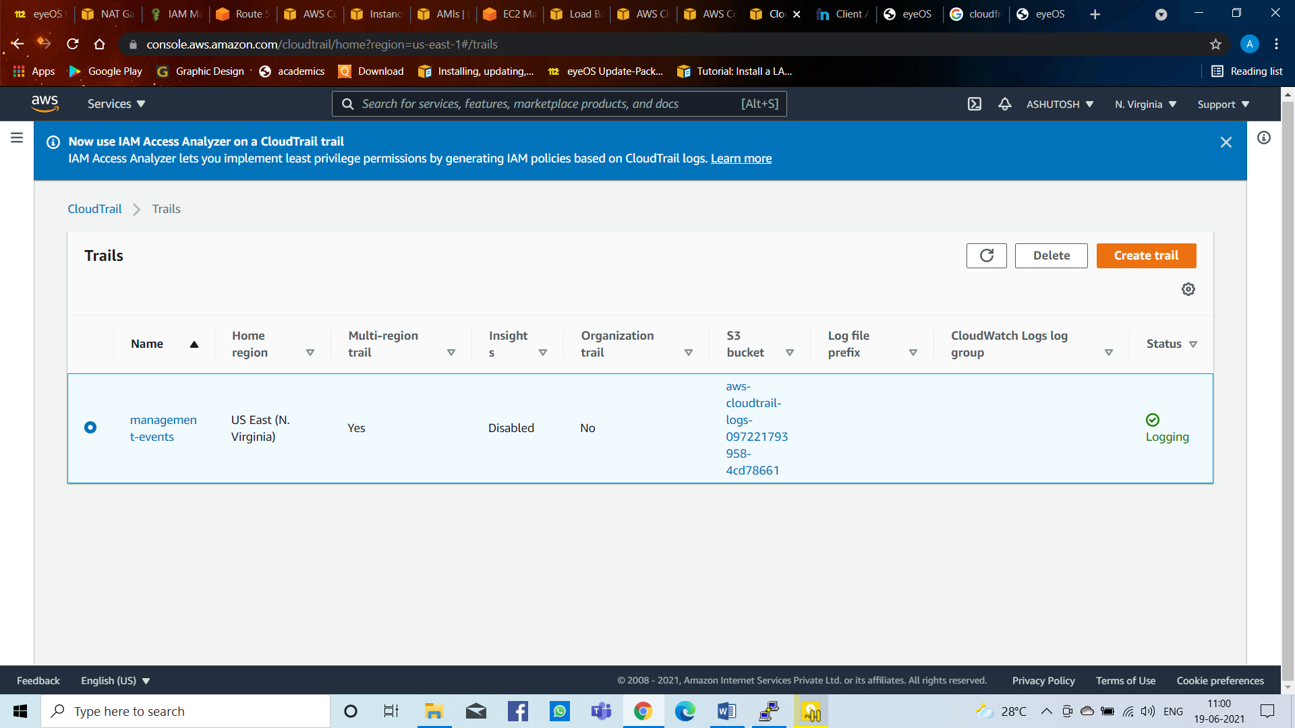

**Figure 37: Create CloudTrail**

After stopping the machine automatically the one machine have been created due to Auto Scaling

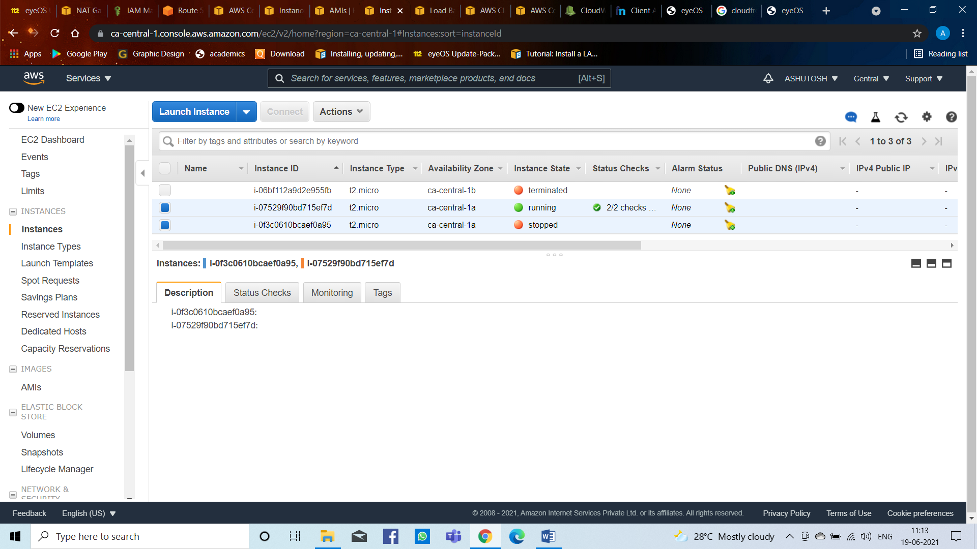

**Figure 38: After stopping the machine automatically another machine created**

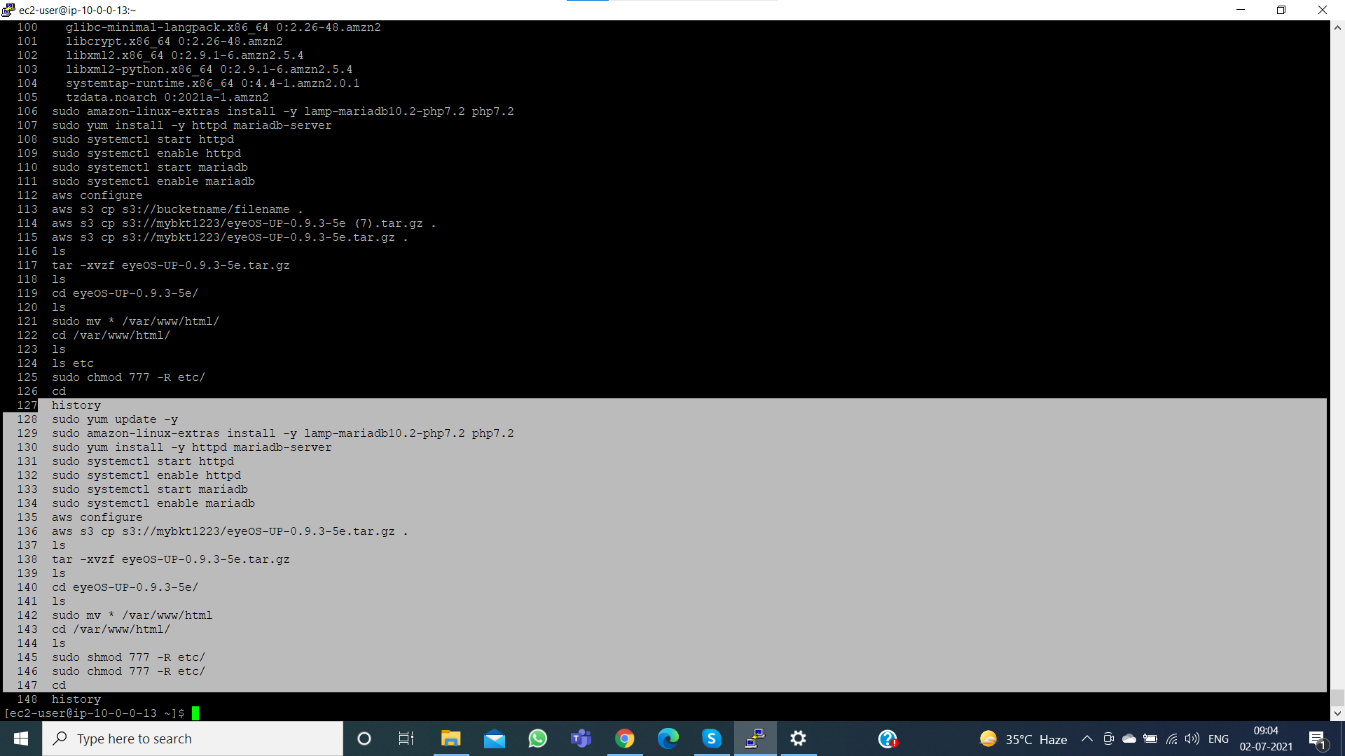

**Figure 39: Commands Run on Putty Software**

**CONCLUSION**

AWS provides building blocks that you can assemble quickly to support virtually any workload. With AWS, you’ll find a complete set of highly available services that are designed to work together to build sophisticated scalable applications. You have access to highly durable storage, low-cost compute, high-performance databases, management tools, and more. All this is available without up-front cost, and you pay for only what you use. These services help organizations move faster, lower IT costs, and scale. AWS is trusted by the largest enterprises and the hottest start-ups to power a wide variety of workloads, including web and mobile applications, game development, data processing and warehousing, storage, archive, and many others.

AWS provides number of tools to simplify and automate the provisioning of infrastructure and deployment of applications; each deployment service offers different capabilities for managing applications. To build a successful deployment architecture, evaluate the available features of each service against the needs your application and your organization.

In this project I have given the full security to the website by using AWS Services i.e. EC2 (AMI, Load Balancer, Auto Scaling), IAM, VPC, SNS, CloudWatch, CloudTrail, CloudFront and more. By using this services the site has been secure i.e. https. In this machine if the traffic load increases automatically one new machine created.

**REFERENCES**

* 1. Akela - Cloud Computing.doc - PDF – Available - <https://akela.mendelu.cz>
  2. Amazon AWS - Overview of AWS – PDF – Available – <https://media.amazonwebservices.com>
  3. Amazon AWS - Overview of AWS – PDF – Available – <https://media.amazonwebservices.com>
  4. What is AWS – Amazon Web Services (AWS) – Cloud Computing – 2021 - Available – <https://aws.amazon.com>
  5. EC2 – Amazon Web Services (AWS) – Cloud Computing – 2021 - Available – <https://aws.amazon.com/ec2/?ec2-whats-new.sort-by=item.additionalFields.postDateTime&ec2-whats-new.sort-order=desc>
  6. Auto Scaling – Amazon Web Services (AWS) – Cloud Computing – 2021 - Available – <https://aws.amazon.com/autoscaling/>
  7. Elastic Load Balancer – Amazon Web Services (AWS) – Cloud Computing – 2021 - Available – <https://aws.amazon.com/elasticloadbalancing/?whats-new-cards-elb.sort-by=item.additionalFields.postDateTime&whats-new-cards-elb.sort-order=desc>
  8. Virtual Private Cloud – Amazon Web Services (AWS) – Cloud Computing – 2021 - Available – <https://aws.amazon.com/vpc/?vpc-blogs.sort-by=item.additionalFields.createdDate&vpc-blogs.sort-order=desc>
  9. Route 53 – Amazon Web Services (AWS) – Cloud Computing – 2021 - Available – https://aws.amazon.com/route53/
  10. S3 – Amazon Web Services (AWS) – Cloud Computing – 2021 - Available – <https://aws.amazon.com/s3/>
  11. EBS – Amazon Web Services (AWS) – Cloud Computing – 2021 - Available – <https://aws.amazon.com/ebs/?ebs-whats-new.sort-by=item.additionalFields.postDateTime&ebs-whats-new.sort-order=desc>
  12. CloudFront – Amazon Web Services (AWS) – Cloud Computing – 2021 - Available – <https://aws.amazon.com/cloudfront/>
  13. SQS – Amazon Web Services (AWS) – Cloud Computing – 2021 - Available – <https://aws.amazon.com/sqs/>
  14. SNS – Amazon Web Services (AWS) – Cloud Computing – 2021 - Available – <https://aws.amazon.com/sns/?whats-new-cards.sort-by=item.additionalFields.postDateTime&whats-new-cards.sort-order=desc>
  15. IAM – Amazon Web Services (AWS) – Cloud Computing – 2021 - Available – <https://aws.amazon.com/iam/>
  16. CloudTrail – Amazon Web Services (AWS) – Cloud Computing – 2021 - Available – <https://aws.amazon.com/cloudtrail/#:~:text=AWS%20CloudTrail%20is%20a%20service,actions%20across%20your%20AWS%20infrastructure>.
  17. CloudWatch – Amazon Web Services (AWS) – Cloud Computing – 2021 - Available – <https://aws.amazon.com/cloudwatch/>
  18. 123seminarsonly – EyeOS Project Report – EyeOS – 2013 – Available - <http://www.123seminarsonly.com/CS/EyeOS.html>
  19. Snapshot - Project Screenshot – AWS – Management Console – Cloud Computing – 2021 – Available - <https://aws.amazon.com/console/>
  20. AWS – Cloud Computing – 2021 – Available - <https://aws.amazon.com/> (Any other information we can get through this site)
  21. AWS – Amazon Linux 2 AMI Command – 2021 – Available - <https://docs.aws.amazon.com/AWSEC2/latest/UserGuide/ec2-lamp-amazon-linux-2.html>
  22. eyeOS – S3 Upload – eyeOS-UP-0.9.3-5e – 2021 – Available - <https://eyeos-update-pack.soft112.com/download.html>
  23. Freenom Website – Domain – 2018 – Available - <https://www.freenom.com/en/index.html?lang=en>